Nottingham Trent University

School of Science and Technology

Eco Vision

A Deep Learning Model for Detecting Disease within Plan Leaves

by

Rohan Pancholi

in

2024

Project report in part fulfilment

of the requirements for the degree of

Bachelor of Science with Honours

In

Computer Science with Artificial Intelligence

I hereby declare that I am the sole author of this report. I authorise the Nottingham Trent University to lend this report to other institutions or individuals for the purpose of scholarly research.

I also authorise the Nottingham Trent University to reproduce this report by photocopying or by other means, in total or in part, at the request of other institutions or individuals for the purpose of scholarly research.



Rohan Pancholi

Abstract

This work introduces an innovative approach to combating plant diseases, a persistent threat to global agriculture and domestic gardening, through the use of deep learning technologies. The project investigates the application of convolutional neural networks (CNNs) for the automatic detection and classification of plant diseases using digital images of plant leaves. The CNN model was trained on a curated dataset consisting of thousands of images categorised into healthy and various diseased states.

The method proved partially successful; it achieved high accuracy in identifying common plant diseases, outperforming traditional visual inspection methods significantly. This success demonstrates the potential of machine learning in transforming disease management practices by providing rapid, accurate diagnostics accessible to both commercial farmers and home gardeners. The developed web interface further supports this accessibility, enabling users to easily upload images for diagnosis, thus facilitating early detection and potentially reducing crop loss.

The study's findings suggest that with further refinement and expansion of the dataset to include a wider range of diseases and plant species, this approach could be universally applicable, offering a scalable solution to one of agriculture's most pressing challenges.

Acknowledgements

I extend my sincere thanks to Dr. Osman Taha for his guidance and expert advice throughout this project. His support was crucial in the development of my research and methodologies.

Appreciation is also due to the technical staff of the Computer Science Department at Nottingham Trent University for their assistance with the software and tools needed for my work.

Table of Contents

Abstract ii

Acknowledgements iii

Table of Contents iv

List of Figures x

List of Tables xiii

CHAPTER 1 1

Introduction 1

1.1 Introduction 1

1.2 Significance of Project 2

1.3 Aims and Objectives 3

1.3.1 Aims 3

1.3.2 Objectives 3

1.4 Roadmap 4

1.4.1 Context and Literature Review 4

1.4.2 Analysis of Literature 4

1.4.3 Implementation 5

1.4.4 Results 5

1.4.5 Conclusion 5

CHAPTER 2 7

CONTEXT 7

2.1 Introduction 7

2.2 Common Plant Disease and Causes 8

2.3 Methods of Detecting Plant Disease 9

2.3.1 Past Methods 9

2.3.2 Current Methods 11

2.3.3 Future Methods 13

2.4 Challenges of Disease Detection using Traditional Methods 14

2.5 Questionnaire Review 15

2.6 Machine Learning Algorithms for Image Classification 17

2.6.1 Challenges in Image Classification 18

2.6.2 How CNN address these Challenges 19

2.6.3 Overview of Machine Learning Algorithms 21

2.6.4 Application of CNNs in Image Classification 26

2.6.5 Competitor Analysis 28

CHAPTER 3 32

New Ideas 32

3.1 Introduction 32

3.1.1 Addressing the Gaps 33

3.2 Basis and Content 34

3.3 Functional and Non-Functional Requirements 35

3.3.1 Machine Learning Functional Requirements 35

3.3.2 Machine Learning Non-Functional Requirements 36

3.3.3 Web Application Functional Requirements 37

3.3.4 Web Application Non-Functional Requirements 38

3.4 Secondary Functional and Non-Functional Requirements 38

3.4.1 Secondary Machine Learning Functional Requirements 38

3.4.2 Secondary Machine Learning Non-Functional Requirements 39

3.4.3 Secondary Web Application Functional Requirements 40

3.4.4 Secondary Web Application Non-Functional Requirements 41

3.5 Diagrams and Visual Aid 41

3.5.1 Functional Diagrams 41

3.5.2 UI Mock-Ups 45

CHAPTER 4 47

IMPLEMENTATION or INVESTIGATION 47

4.1 Introduction 47

4.2 Development Methodology 48

4.3 Project Planning and Time Management 50

4.3.1 Workload Estimation 50

4.4 Tools and Technologies 54

4.4.1 IDE 54

4.4.2 Languages 54

4.4.3 Libraries 57

4.5 Machine Learning Development 59

4.5.1 Data Gathering 59

4.5.2 Data Visualisation 60

4.5.3 Data Pre-processing 60

4.5.4 Model Architecture 65

4.6 Website Development 67

4.6.1 Importance of HCI Principles 67

4.6.2 Design Principles 69

4.6.3 Front end Technologies 71

4.6.4 Back End Technologies 72

4.6.5 Implementation Challenges 73

CHAPTER 5 75

RESULTS / DISCUSSION 75

5.1 Introduction 75

5.2 Methodology Recap 76

5.2.1 Testing Setup 76

5.2.2 Evaluation Criteria 77

5.3 Model Unit Testing 77

5.4 Model Performance 80

5.4.1 Training and Validation Accuracy and Loss Metrics 80

5.4.2 Testing Accuracy and Loss 83

5.4.3 F1 Score 84

5.5 Website Testing 85

5.6 Discussion 89

CHAPTER 6 92

CONCLUSIONS / FUTURE WORK 92

6.1 Conclusions 92

6.2 Future work 93

6.3 Legal, Social, Ethical and Professional Issues 95

6.3.1 Legal 95

6.3.2 Social 95

6.3.3 Ethical 95

6.3.4 Professional Issues 96

6.3.5 Impact Analysis 96

6.4 Synoptic Reflections 96

ReferenceS 99

Bibliography 103

Appendix 104

List of Figures

Figure 1 - Question 1 104

Figure 2 - Question 2 104

Figure 3 - Question 3 105

Figure 4 - Question 4 105

Figure 5 - Question 5 106

Figure 6 - Question 6 106

Figure 7 - Question 7 107

Figure 8 - Question 8 107

Figure 9 - Gantt Chart 108

Figure 10 - User Flow Diagram 109

Figure 11 - Sequence Diagram 109

Figure 12 - Home Page UI 110

Figure 13 - Home Page UI | Incorrect File Format 110

Figure 14 - Home Page UI | Image Classified 111

Figure 15 - Dataset Page UI 111

Figure 16 - Feedback / Help UI 112

Figure 17 - Bar graph representing Diseased Categories File Counts 113

Figure 18 - Bar graph representing Health Categories File Counts 113

Figure 19 - Bar Graph after reducing max image count 114

Figure 20 - Image augmentation code 114

Figure 21 - Dataset after augmentation 115

Figure 22 - Model Architecture 116

Figure 23 - Test count files in directory 116

Figure 24 - File count after Image Cap 116

Figure 25 - File count after Image Augmentation 117

Figure 26 - Image Example after Image Augmentation 117

Figure 27 - Image Resize Test 118

Figure 28 - Test Remove Corrupted Files 118

Figure 29 - Test Model Training 119

Figure 30 - Training and Validation Accuracy 120

Figure 31 - Training and Validation Loss 121

Figure 32 - Test Accuracy and Loss 121

Figure 33 - F1 Score 122

Figure 34 - Image Upload Test 122

Figure 35 - Correct Prediction Output 122

Figure 36 - Filters Test in Dataset 123

**Figure 37 - Accurate Descriptions for Plants with Disease** 123

List of Tables

Table 1 - Image Augmentation Parameters 61

Table 2 - Model Unit Testing Table 78

Table 3 - Training and Validation Accuracy and Loss Metrics 81

Table 4 - Website Functionality Testing 86



Introduction

Introduction

In the continually evolving landscape of agriculture, the prevalence of disease in plant leaves casts a significant shadow over crop health and global food security. As noted in The Journal of Agricultural Science, "Pathogens are estimated to cause around 12.5% of global crop losses" (Oerke, 2006). However, the impact of these diseases extends beyond vast agricultural fields, reaching into home gardens and affecting individuals passionate about plants.

While global food security commands significant attention and resources, it is vital not to overlook the importance of supporting domestic gardeners who cultivate for pleasure. For many, spending time in the garden is not just a hobby but a cherished pastime that brings sentimental joy and a profound connection to nature. Whether it's nurturing an array of flowers in a back garden, cultivating a vegetable patch in an allotment, or caring for one's first house plant, gardening fosters a sense of fulfilment.

Yet, like many idyllic pursuits, this pastime is threatened by the presence of diseases in plant leaves. Domestic gardeners often lack the knowledge and resources that farmers might have, making their plants susceptible to diseases that can diminish their aesthetic appeal and erode the enjoyment derived from gardening.

In response to these challenges, there is a pressing need for accessible and effective tools to aid in the early detection and management of plant leaf diseases in domestic settings.

This project aims to cater to the entire spectrum of gardening enthusiasts, from large-scale agricultural farmers to those in domestic settings, with a particular focus on the latter. The main goal of this project is to leverage machine learning techniques, specifically image detection, to streamline the process of identifying diseases in plant leaves. This initiative aims to democratise access to this technology through a user-friendly application or website, enabling individuals at every level of plant care to access the necessary tools to detect and manage plant diseases free of charge.

## Significance of Project

Despite the escalating severity of diseases in plant leaves, a noticeable gap remains in efforts to address these issues within domestic environments. Evidence indicates that the incidence of plant diseases is rising, driven by factors such as climate change, globalisation, and the intensification of agricultural practices. Studies conducted by renowned agricultural research institutions, including the Food and Agriculture Organisation (FAO) and the International Maize and Wheat Improvement Centre (CIMMYT), have highlighted the increasing prevalence of plant diseases worldwide.

While significant attention and resources are dedicated to combating plant diseases in large-scale agricultural settings, little emphasis has been placed on disease management within domestic environments. Home gardeners, amateur gardeners, and urban green spaces constitute a substantial portion of the plant ecosystem, yet they often lack access to effective tools and resources for disease diagnosis and management.

In today's world, characterised by rapid technological advancement, more individuals are relying on technology to assist them in their daily lives. Traditional manual techniques for detecting diseases in plant leaves are increasingly viewed as outdated and insufficient for addressing the growing challenges posed by plant diseases. With the advent of machine learning and image detection technologies, there is a transformative opportunity to revolutionise how we manage plant health. This shift towards technology-driven solutions offers unique opportunities to improve agricultural practices, safeguard food security, and promote environmental sustainability.

## Aims and Objectives

### Aims

The primary aim of this project is to utilise machine learning techniques and image detection to develop a model that can accurately detect diseases in plant leaves. Additionally, this model will be implemented on a user-friendly platform, such as a website or app, and deployed publicly at no cost, making it accessible to all individuals with a passion for plants.

### Objectives

1. **Data Collection and Development**: Assemble a comprehensive database of images of plant leaves, both healthy and diseased, to support the training of the machine learning model.
2. **Data Pre-processing**: Normalise and balance the dataset to ensure that the machine learning model is not biased towards any specific condition or type of data.
3. **Data Analysis**: Examine the structure of the data and apply techniques to ensure the dataset is balanced, enhancing the model's ability to generalise across various types of plant diseases.
4. **Machine Learning Implementation**:
   * + - 1. Design and implement appropriate machine learning algorithms.
         2. Train and fine-tune the model to achieve the highest possible accuracy.
5. **Website Development**:
   * + - 1. Develop a user-friendly and aesthetically pleasing interface for the website that allows users to easily navigate and use the application.
         2. Create robust back-end functionality that can process images uploaded by users and accurately classify them as healthy or diseased based on the trained model.

## Roadmap

### Context and Literature Review

The paper will begin with an extensive review of the relevant literature, incorporating both primary research and case studies. This review will explore the global and domestic impacts of plant diseases, highlighting the effects on large-scale farms and presenting survey results that illustrate the consequences in domestic environments. Additionally, it will cover past, present, and future strategies for detecting and managing plant diseases, with a focus on potential machine learning methods that could help achieve the research objectives.

### Analysis of Literature

Following the literature review, the paper will evaluate the positive and negative aspects of the reviewed literature, identifying gaps in the market and areas for improvement. It will also discuss how this project aims to bridge these gaps, providing a detailed explanation of the mechanics of the proposed solution, including machine learning techniques, software requirements, and user interface (UI) diagrams.

### Implementation

The Implementation chapter will detail the chosen methodology used to plan and build the project. It will outline the programming languages employed and provide a rationale for their selection. This chapter will also provide a step-by-step explanation of the two main components used to achieve the end goal: data gathering and model production, as well as HTML production for the user interface.

### Results

In the Results section, the findings of the project will be presented, including the performance of the developed model in detecting plant diseases and the functionality of the HTML production. This section will showcase the results of testing and validation processes, encompassing model accuracy, speed, and usability metrics.

### Conclusion

The conclusion will place the project within its aims and objectives, as well as the broader context of prior work in the field. It will offer a thorough understanding of future actions by identifying ongoing gaps in the market and suggesting areas for improvement. Additionally, insights into Landscape, Environment, Society, and Policy Issues (LESPIs) related to plant health management will be discussed. The conclusion will also assess the project's success, supported by references to results and outcomes, and reflect on the development of skills during the project and their relevance to employability aspirations.



CONTEXT

Introduction

One of the primary challenges in plant health management is the early detection, prevention, and mitigation of diseases, particularly in a domestic setting where gardening is often more of a pastime than a profession. Domestic gardeners, who typically balance their gardening activities with regular jobs, may not have extensive knowledge or resources pertaining to plant diseases. As a result, they often recognise the signs of disease only when it has progressed too far to be effectively treated, highlighting the need for accessible information and early detection methods tailored to non-professionals.

As Lovell-Read et al. (2023) point out, this challenge is compounded by many plant diseases having a long presymptomatic period, during which the infection may spread undetected to other plants. This delay from initial infection to symptom onset in globally important hosts often allows the disease to establish itself without detection. There exists a significant opportunity to leverage advancements in technology, such as mobile apps, online platforms, and educational materials, to bridge the gap between professional agricultural expertise and the needs of amateur gardeners, thereby helping to prevent the further spread of plant diseases.

## Common Plant Disease and Causes

Recent research highlights an increase in plant diseases caused by bacterial, fungal, and viral infections (Nazarov et al., 2020). The factors contributing to these diseases can originate from a multitude of sources, divided into biotic and abiotic categories.

Biotic factors, also known as infectious factors, are primarily caused by living organisms. These include a wide range of agents such as pathogens, pests, competitive organisms, and parasitic plants, each playing a distinct role in affecting plant health. Pathogens, including fungi, bacteria, viruses, nematodes, and other microorganisms, invade plant tissue and disrupt cellular functions. Pests, such as insects, mites, rodents, and other animals, inflict direct damage on plants through their feeding activities and also act as vectors for disease transmission. Competitive organisms, like weeds, engage in a relentless battle for crucial resources such as water, light, and nutrients, which hinders plant growth and diminishes crop yields. Moreover, parasitic plants compound these challenges by extracting essential nutrients from their hosts, thereby weakening them and increasing their susceptibility to diseases.

Abiotic factors are environmental conditions that impact plant health. These include environmental stress, soil conditions, nutrient levels, pollution, and physical damage to the plant. Diseases caused by abiotic factors can result in characteristic symptoms such as leaf spots or wilting, affecting both the biological health of the plant and its visual appearance. This distinction between biotic and abiotic factors is crucial for understanding the comprehensive landscape of plant health issues and underscores the importance of tailored approaches to disease management and prevention.

## Methods of Detecting Plant Disease

The field of plant disease detection has undergone significant evolution, adapting to advancements in technology that often build upon or replace older methods. While modern technologies are increasingly developed to detect and mitigate diseases in plant leaves, it's crucial not to disregard the traditional methods that were employed before the digital revolution in the late 20th century.

Historically, methods such as visual inspection, symptom-based identification, and laboratory-based diagnostic techniques were predominant. These traditional approaches are still utilised to some extent today, providing a foundational understanding of plant pathology. However, modern approaches offer faster and more precise results, significantly enhancing the efficiency and scope of disease detection.

For example, remote sensing technologies, which include the use of drones or satellites, allow for the monitoring of vast agricultural areas from a broader perspective, enabling the detection of disease outbreaks before they become widespread. Additionally, machine learning algorithms can process and analyse large datasets to identify subtle patterns and symptoms of diseases that might be too minute for the human eye to detect. These advancements represent a significant shift from conventional methods, offering more proactive and scalable solutions for managing plant health.

### Past Methods

#### Visual Observation

Visual observation has long been a fundamental method for detecting disease in plant leaves. Before the advent of advanced technology and molecular techniques, farmers relied primarily on their observational skills and the knowledge passed down through generations to identify diseases in plants. As noted by Khakimov et al. (2022), "By visual observation, it is often possible to determine the primary pathogenesis of a nematode, fungus, bacterium, or virus depending on the signs present in the plant sample." However, visual observation alone may not yield a definitive diagnosis, as conclusions were often based solely on aesthetic observations, which may not capture the full extent of the disease.

#### Microscopy

The introduction of the microscope in the late 16th century marked a significant advancement in plant disease detection, allowing for a much finer scale of inspection. After initial visual observation, affected plant parts were often taken to a laboratory for more detailed microscopic examination. Under the microscope, detailed analysis of the plant's pathology could be conducted, focusing on elements such as hyphae, microsclerotia, conidiophores, conidia, and bacterial cell clusters of pathogenic fungi (Khakimov et al., 2022). However, even microscopy has its limitations, as some fungi may not produce spores on the parts of the plant that are being examined, making it difficult to detect the disease with this method alone.

#### Molecular Techniques

Molecular techniques have revolutionised plant disease detection by providing a highly precise and efficient alternative to earlier methods such as visual observation and microscopy. By extracting DNA or RNA from the plants, laboratory scientists can employ techniques like DNA sequencing to identify the specific genetic code of the disease. A comparative analysis is then conducted by comparing the obtained sequences with known sequences in databases to pinpoint the exact species of the pathogen. This advancement significantly enhanced the accuracy of disease identification, offering a more nuanced understanding of plant health and setting the stage for further innovations in the field.

### Current Methods

#### Remote Sensing and Imagery

Remote sensing technology, which dates back over 150 years to the invention of the camera, has undergone significant evolution. Originally emerging in the 1840s with balloon-based topographic mapping, a key development occurred in 1931 with the introduction of colour infrared photography, which has been widely adopted in agriculture and forestry. Today, remote sensing includes a variety of techniques such as visible, infrared, multispectral, and thermal sensing, each capturing different aspects of the electromagnetic spectrum.

According to Anand Choudhary (2022), remote sensing is a rapid and efficient method for obtaining and analysing the spectral properties of Earth's surfaces from various distances. This technology is particularly beneficial for large-scale farms to assess the spread of plant diseases comprehensively. It allows for the assessment of disease over vast areas, providing an overview of both the spread and intensity of plant diseases. It also helps in understanding the relationship between plant diseases and environmental factors, offering insights into disease dynamics and enabling

#### Thermography

Thermography, another imaging technique, leverages the principle that a plant’s temperature is indicative of its physiological state. Changes in physiological conditions such as photosynthesis, transpiration, stomatal conductance, and even cell death can occur during plant-pathogen interactions. As noted by Xu et al. (2006), thermography allows for the non-destructive, contact-free assessment of plants. However, interpreting thermal images requires expertise, as various factors can influence plant temperature. Additionally, the specific thermal signatures associated with different diseases can vary, and it is often recommended to validate findings with other diagnostic methods for accurate disease identification.

#### Plant Health Lateral Flow Tests

While many discussed methods are suited for large-scale agricultural applications and require substantial funding, detecting diseases within home settings is becoming a niche area, with innovations like plant health lateral flow tests emerging. One such product is from a company called "Pocket Diagnostic," designed to identify plant diseases quickly and effectively. These tests, although simple to use, come with limitations. For instance, they must be ordered online, which involves a waiting period for delivery. From the user’s perspective, there is also uncertainty regarding the accuracy of these tests and the range of diseases they can detect. Some tests may only identify specific diseases or pathogens, limiting their overall utility. In cases where a new or uncommon disease appears, existing tests may not be equipped to detect it.

### Future Methods

#### Robotic Farming Systems

Robotics and artificial intelligence are at the forefront of cutting-edge technology in agriculture, poised to revolutionise current disease detection methods. These technologies can enhance efficiency, precision, and sustainability in agricultural practices. For instance, autonomous farm vehicles equipped with advanced sensors, including thermography or imaging technologies, can continuously monitor the health of plants either up close or from a distance. The potential adoption of such technologies could significantly improve the precision and cost-effectiveness of farming practices, especially in disease detection. This advancement could reduce the resources required for disease management and enhance efficiency. Moreover, the rapid detection capabilities of autonomous farming systems could lead to the near elimination of plant diseases, given that the shortened timeframe for disease detection could prevent the spread before it becomes significant.

However, it's important to consider the potential challenges associated with such advanced technologies. The development and widespread implementation may encounter significant hurdles, with prototypes potentially taking many years, if not decades, to fully materialise and become mainstream.

#### Responsive Materials

Responsive materials are those that react to the presence of or changes in external stimuli, such as light, temperature, magnetic fields, or electricity (Bril et al., 2022). These materials have promising applications in detecting diseases in plant leaves. For example, if a plant is suspected of harbouring a disease, farmers could apply responsive materials designed to detect changes in biochemical markers, volatile organic compounds, or other indicators of disease. These materials can exhibit various reactions, including changes in colour, which can be fine-tuned to display different colours corresponding to specific diseases.

Moreover, the versatility of responsive materials extends to environmental monitoring. By using materials sensitive to changes in humidity or temperature, it becomes possible to gain insights into environmental conditions that are conducive to pathogen development. This real-time monitoring capability can contribute to early disease detection and inform decision-making in agricultural practices. While the direct implementation of responsive materials in plant disease management is still an area of ongoing research, their adaptability and diverse applications hold great promise. These innovative materials offer novel possibilities for mitigating the impact of diseases in agriculture and could potentially find applications in home gardening as well. The ongoing exploration of responsive materials opens new avenues for advancing our understanding and management of plant health.

## Challenges of Disease Detection using Traditional Methods

Traditional methods for plant disease detection, such as visual inspection and laboratory-based examinations, confront several significant challenges that highlight the need for more efficient and accurate techniques. Visual inspection, while one of the most accessible and common methods, depends heavily on the expertise of the observer and is prone to human error. This method often fails to detect diseases at early stages because many plant diseases do not exhibit visible symptoms until they have progressed significantly. By this advanced stage, effective management of the disease can become difficult, and in some cases, impossible, thereby reducing the chances of successful intervention (Buja et al., 2021).

Furthermore, traditional laboratory-based methods, including polymerase chain reaction (PCR) and enzyme-linked immunosorbent assay (ELISA), although offering greater accuracy, are generally time-consuming and require specialsed equipment. These factors make them impractical for rapid, in-field diagnostics, limiting their usefulness in immediate and accessible disease management (Kaur and Sharma, 2021).

Such methods, while effective in certain contexts, often struggle with the early detection of asymptomatic infections, which is crucial for preventing the spread of pathogens before visible symptoms develop. This early detection is especially important in cases involving pathogens like Xylella fastidiosa, which is responsible for severe diseases in olive trees and other crops. The pathogen can spread undetected due to the latent period between infection and symptom development, complicating efforts to control its spread and mitigate its impact (Buja et al., 2021).

These challenges underscore the necessity for developing new, more effective methods for plant disease detection that can offer rapid, accurate, and field-applicable solutions to enhance agricultural productivity and plant health management.

## Questionnaire Review

To obtain accurate and up-to-date data about individuals who purchase plants for pleasure or as a hobby, a primary research method was adopted, utilising Google Forms to conduct a questionnaire. This approach targeted a more accessible demographic compared to agricultural farmers, aiming to gain a deeper understanding of the challenges faced by home gardeners and plant enthusiasts. The questionnaire comprised eight questions, both open and closed, designed to gather insights into the broader context of why disease prevention is crucial not only in agriculture but also in domestic settings.

* **Ownership and Purchase Habits:**
  + Do you own any plants or crops?
  + How regularly do you buy plants?
* **Factors Influencing Plant Purchases:**
  + What factors influence your decisions to buy plants?
* **Plant Health and Mortality:**
  + On a scale of 1 to 10, with 10 being "your plants are as healthy as they can be," how many of your plants die?
* **Challenges in Plant Maintenance:**
  + Have you faced any challenges in maintaining your plants? If yes, please explain why.
* **Disease and Blemishes Observation:**
  + Have you ever noticed disease or blemishes in your plant leaves?
* **Interest in Disease Detection Technology:**
  + Do you wish there was something on the market to detect early disease in plant leaves?
  + Would this technology encourage you to buy more plants and enhance your enjoyment of the hobby, knowing you can prevent early death in plants?

Key Findings from the Questionnaire:

* **Ownership and Engagement**: 83% of respondents own plants, with diverse frequencies of purchases, reflecting various levels of engagement in gardening.
* **Perceived Plant Health**: Participants generally rated the health of their plants moderately high, though issues leading to plant deaths were reported.
* **Common Challenges**: Respondents frequently mentioned challenges such as neglect, time constraints, lack of knowledge in plant care, and environmental factors impacting plant health.
* **Disease Observation**: A significant portion of respondents has observed diseases or blemishes in their plants' leaves.
* **Interest in Technology**: There is a notable interest in technology for early disease detection, indicating a collective desire for preventive measures.
* **Potential Impact of Technology**: The introduction of technology to detect early plant diseases could positively affect respondents' enjoyment of their gardening hobby, potentially leading to increased plant acquisition and an enhanced overall experience.
* **Specific Challenges Reported**: Difficulties in maintaining succulents, issues with plant growth, and uncertainty about the causes of plant health problems were commonly reported.

The analysis of the questionnaire responses provided valuable insights into the habits and challenges of home gardeners and plant enthusiasts. It highlighted a keen interest in technological solutions for early disease detection, with potential benefits including increased plant longevity, improved care practices, and enhanced enjoyment of the gardening hobby. The findings also emphasise the need for targeted interventions addressing common challenges faced by plant owners, particularly related to environmental factors and knowledge gaps in plant care.

## Machine Learning Algorithms for Image Classification

Machine learning, a subset of artificial intelligence, enables systems to learn from data, identify patterns, and make decisions with minimal human intervention. Image classification, a critical application of machine learning, involves the automatic categorization of images into distinct classes. This capability has far-reaching applications across various fields, from medical diagnosis to environmental monitoring, offering significant enhancements in speed and accuracy over traditional methods.

### Challenges in Image Classification

#### High Dimensionality in Image Data

A significant challenge in image classification is the high dimensionality of image data. Each image comprises thousands of pixels, each acting as an individual feature (LeCun, Bengio, & Hinton, 2015). Traditional machine learning algorithms, when faced with processing this vast amount of information, encounter significant computational challenges. High dimensionality can lead to difficulty in extracting meaningful patterns without encountering the "curse of dimensionality," where the feature space becomes so large that the available data is sparse, increasing the risk of the model overfitting (Krizhevsky, Sutskever, & Hinton, 2012).

#### Variability and Invariance

Another challenge in image classification is the variability and invariance in images of the same object due to changes in angle, lighting, scale, and deformation. Traditional algorithms struggle to account for this variability without a complex and manual feature extraction process (Szegedy et al., 2015). Additionally, these algorithms often fail to recognize the same object if it appears differently in various contexts, leading to inconsistency and inaccuracy in classification results.

#### Feature Extraction and Selection

Before the rise of deep learning, feature extraction in image classification required substantial domain expertise. Selecting which features to extract and how to represent them for the machine learning model was largely a manual process, heavily reliant on the intuition and experience of the data scientist. This approach was not only labour-intensive but also introduced a level of subjectivity and potential for oversight (Zeiler & Fergus, 2014).

These challenges underscore the complexity of image classification and the need for advanced solutions such as deep learning, which can automate feature extraction and provide more robust handling of high-dimensional data and image variability.

### How CNN address these Challenges

#### Automatic Feature Extraction

Convolutional Neural Networks (CNNs) revolutionise the process of feature extraction by automating the detection and learning of the most relevant features from images, eliminating the need for manual intervention. Through convolutional layers, CNNs apply various filters to input images, creating feature maps that accentuate specific features such as edges, textures, or patterns. This automation makes the feature extraction process far more efficient and significantly less prone to human error, enabling the model to learn more effectively directly from the data.

#### Hierarchical Feature Extraction

CNNs learn features in a hierarchical manner. Initial layers capture basic features like edges and textures, while deeper layers integrate these basic features into more complex representations. This hierarchical learning is crucial for handling the variability and complexity of images, enhancing the model's ability to generalise across different representations of the same object. By understanding both simple and complex aspects of images, CNNs can adapt to new and varied data with greater accuracy.

#### Dimensionality Reduction Robustness to Variability

CNNs incorporate pooling layers that reduce the dimensionality of the feature maps, significantly lowering both the computational cost and the risk of overfitting. Pooling layers summarise the features in a region of the feature map, thus preserving essential information while discarding irrelevant details. This step is crucial for managing the high dimensionality of image data, making the model more efficient and robust.

Furthermore, CNNs exhibit a degree of inherent invariance to scale, translation, and distortion due to their architectural design. The combination of convolutional layers, which learn spatial hierarchies of features, and pooling layers, which provide spatial invariance, allows CNNs to recognise objects regardless of slight variations in appearance within images. This robustness is vital for achieving high accuracy in image classification tasks under diverse conditions.

Overall, the capabilities of CNNs to automatically extract and hierarchically organise features, reduce dimensionality, and maintain robustness to image variability make them exceptionally suited for advanced image classification tasks, overcoming many limitations of traditional methods.

### Overview of Machine Learning Algorithms

Machine learning algorithms are broadly categorised into traditional algorithms and deep learning methods. Traditional algorithms include supervised learning, unsupervised learning, and reinforcement learning, each offering robust solutions to a variety of problems. However, the advent of deep learning has introduced new capabilities and approaches to these challenges, significantly enhancing the complexity and types of problems that can be addressed.

#### Support Vector Machines

Support Vector Machines are a powerful type of supervised learning models used primarily for classification and regression tasks. They operate by finding the optimal hyperplane that best separates different classes in the feature space. SVMs are particularly effective in high-dimensional spaces and are well-suited for situations where the number of dimensions exceeds the number of samples, making them robust against overfitting in such scenarios (Cortes & Vapnik, 1995).

#### Random Forests

Random Forests are an ensemble learning method used for classification, regression, and other tasks. This method involves constructing multiple decision trees during the training phase and producing the output based on the mode of the classes (in classification tasks) or the mean prediction (in regression tasks) of the individual trees. Random Forests are known for their high accuracy, robustness, and ease of use, making them highly effective for a wide range of problems (Breiman, 2001). They handle large data sets with higher dimensionality well, and their ensemble approach helps to reduce the risk of overfitting by averaging multiple trees.

Overall, both SVMs and Random Forests offer strong performance in many traditional machine learning tasks. While SVMs excel in high-dimensional data spaces, Random Forests provide a versatile and scalable solution suitable for a wide variety of applications. The choice between these and other traditional algorithms often depends on the specific requirements and constraints of the task at hand, including the nature of the data, the desired accuracy, and the computational resources available.

#### Advantages of Deep Learning over Traditional Methods

Deep learning offers a range of advantages over traditional machine learning methods, particularly in how it handles complex and high-dimensional data. Here are some key benefits that make deep learning particularly powerful in many modern AI challenges:

Automated Feature Extraction

Deep learning algorithms excel at automatically learning the features from data, eliminating the need for manual feature selection. This capability is especially beneficial for tasks involving complex data types like images and speech, where defining features manually can be highly challenging and subjective. This automation not only simplifies the model development process but also enhances the ability of the model to capture essential patterns without human bias.

Handling High Dimensional Data

Deep learning methods are inherently well-suited to manage high-dimensional data, making them ideal for tackling complex problems in fields such as natural language processing (NLP) and computer vision. Traditional methods often struggle with the "curse of dimensionality," where the feature space becomes so large that the model's performance deteriorates or becomes computationally infeasible. Deep learning networks, particularly those with convolutional and recurrent structures, are designed to process and simplify high-dimensional data while preserving important information.

Flexibility and Scalability

The architecture of deep learning models is highly flexible, allowing them to be adapted and scaled to a wide range of problems, from simple classification tasks to complex systems involving millions of input features and intricate patterns. This scalability makes deep learning a versatile tool across industries and applications, capable of addressing both narrowly defined tasks and broad, multifaceted challenges.

Performance

In many scenarios, deep learning methods have outperformed traditional machine learning algorithms, particularly in tasks that involve large volumes of data and complex pattern recognition. Studies such as those by Simonyan and Zisserman (2014) have demonstrated that deep learning models, particularly convolutional neural networks, achieve superior accuracy in image recognition tasks. This level of performance extends to other domains where data complexity and volume exceed the capabilities of traditional algorithms.

#### Layers within CNN

##### Convolutional Layer

The convolutional layer is the core building block of a CNN and performs the mathematical operation known as convolution. This layer applies filters to small portions of the input image to calculate the dot product between the filter’s weights and the pixel values it covers. This operation produces a feature map that highlights specific aspects of the image, such as edges or textures. For example, a filter designed to detect vertical edges might highlight areas with significant intensity changes from left to right. By using multiple filters, each designed for different features, a convolutional layer can produce a stack of feature maps, each representing a different characteristic of the input image.

##### Activation Functions

Following convolution, the values in the feature map are passed through an activation function, such as the Rectified Linear Unit (ReLU). Activation functions introduce non-linearity into the network, enabling it to learn and represent more complex patterns. ReLU is widely used because it is simple and effective; it sets all negative values in the feature map to zero while keeping positive values unchanged, thereby enhancing the network’s ability to differentiate between features.

##### Pooling Layers

Pooling layers reduce the spatial dimensions (width and height) of the input volume following convolutional layers and activation functions. The most common type, max pooling, down samples the input by dividing it into rectangular sections and outputting the maximum value from each section. This reduction not only decreases computational load and memory usage but also contributes to making the network invariant to minor scale and orientation changes in the input images.

##### Fully Connected Layers

Towards the end of the CNN architecture, fully connected layers are used to classify the image based on the features extracted by earlier layers. Each neuron in a fully connected layer is connected to all activations in the previous layer, allowing the network to consider global patterns across the entire input volume.

##### Training CNNs

Training convolutional neural networks is essential for achieving high performance, particularly in tasks such as image classification. Several techniques have been developed to enhance the training process, improve the model’s generalization ability, and prevent overfitting.

##### Data Augmentation

Data augmentation increases the diversity of the training set by applying transformations to the original images, such as rotation, scaling, cropping, flipping, and adjusting brightness or contrast. This helps CNNs learn to recognise objects in images despite variations in appearance and positioning, enhancing the model’s robustness and performance.

##### Dropout

Dropout is a powerful regularisation method used during training. It randomly "drops" a subset of neurons (and their connections) from the network during each training phase, according to a predetermined probability. This prevents the network from relying too heavily on any single feature and encourages the development of more robust and generalisable features.

##### Transfer Learning

Transfer learning leverages a model developed for one task and adapts it for a related task. Often, this involves using a pre-trained model (e.g., one trained on a large dataset like ImageNet) as the starting point for a new task. The general features (like edges and textures) learned by the pre-trained network are typically retained, while only the later, task-specific layers are fine-tuned on the new dataset. This approach can significantly reduce training time and data requirements for developing a high-performing model on the new task.

### Application of CNNs in Image Classification

In recent years, machine learning and particularly deep learning techniques have proven to be powerful tools for detecting diseases in plant leaves. This application has significant implications for the sustainability of agricultural practices, contributing to early disease detection and enhanced management strategies.

One notable contribution in this area is the work by Saleem, Potgieter, and Mahmood Arif in their article, ‘Plant Disease Detection and Classification by Deep Learning’ (2019). This research highlights the role of deep learning in improving accuracy in detecting plant diseases. The authors discuss various deep learning architectures and visualisation techniques developed for detecting and classifying symptoms of plant disease. This study serves as a crucial reference, capturing the current state of research and discussing future technological advancements in plant disease detection through machine learning.

Another important survey by Kaur S, Pandey S, and Goel S explores the challenges and advancements in detecting plant disease using leaf image analysis. This process involves using digital image processing techniques to extract useful information from images of plant leaves (Windias leaf area meter - leaf area measurement system - size of leaf 2024). The survey examines the adoption of various computer vision techniques at different stages, including image acquisition, preprocessing, segmentation, feature extraction, and classification. It also assesses the performance of leading algorithms across various crop and disease types, identifying significant gaps in current research. These gaps particularly relate to the handling of complex image backgrounds and the lack of focused research on specific crops and diseases.

The survey suggests several directions for future research, advocating for the creation of adaptable and comprehensive models that can improve the accuracy and reliability of disease detection. The authors argue for the necessity of such models to handle the complexities of real-world applications effectively.

Real-World Applications and Scaling

While the survey offers a thorough overview of the field, it could be further enhanced by incorporating case studies of real-world applications. These case studies would provide more concrete insights into how these technologies perform outside laboratory settings. Additionally, exploring how these solutions can be scaled and integrated into existing agricultural practices would offer practical perspectives on transitioning from research to real-life usage. This aspect is crucial for bridging the gap between theoretical research and practical implementation, ensuring that advancements in machine learning can have a tangible impact on global agriculture.

### Competitor Analysis

EPIC is described as ‘An automated diagnostic tool for potato late blight disease detection from images” aiming to mitigate crop loss in China by addressing economic losses due to potato disease. (Epic, *An automated diagnostic tool for potato late blight disease detection from images* 2024).

Similar to EPIC, this project employs machine learning algorithms to detect diseases in crops through a graphical user interface (GUI), offering real-time solutions to its users. This shared foundation underscores a mutual aim to mitigate crop loss by enabling early disease detection in plant leaves, highlighting the critical role of technology in revolutionising agricultural practices.

Despite these similarities, there are distinct differences that set it apart. ­EPIC is specifically designed to cater to farmers, with its application tailored to meet the needs of agricultural professionals managing large-scale crop production. In contrast, this project focuses on the domestic sphere of gardening, aiming to make advanced disease detection accessible to home gardeners. This distinction in target audience underscores a broader application of machine learning technology in agriculture, extending its benefits from professional farming contexts to individual gardeners seeking to protect their plants from diseases.

Moreover, EPIC operates on a proprietary software model, which restricts its public availability and limits the scope for collaborative improvement or adaptation by the wider community. This project, conversely, may explore more open or accessible software models to encourage wider adoption and community engagement.

Another significant difference lies in the dataset's focus and composition. EPIC's dataset is meticulously curated to identify specific diseases prevalent in potatoes, such as late blight, early blight, and June disease, offering a targeted approach for potato farmers. On the other hand, this project embraces a broader spectrum of diseases and plants, aiming to cater to a diverse range of gardening needs. This inclusivity enhances its utility for domestic gardeners who may encounter a wide variety of plant health issues

One significant opportunity lies within the domestic tailoring. Customising software to cater specifically to domestic markets could address unique local challenges more effectively. This involves adapting disease detection algorithms to recognise local disease prevalence’s, incorporating regional languages and agricultural practices into the app's content, and collaborating with local agricultural organizations for data collection and validation. Such customisation ensures that the tool is finely tuned to meet specific regional needs, thereby enhancing its relevance and utility.

Another area of potential is public availability. Making a version of the software publicly available or more open for collaboration could democratise access to advanced agricultural technologies. This approach could foster a community-driven development process, where users not only suggest improvements but also contribute to the dataset. It would likely increase adoption rates by making the tool accessible to small-scale farmers and researchers, thereby fostering innovation through diverse user input and collectively accelerating the mitigation of crop diseases worldwide.

Expanding the dataset to include a broader range of plants and diseases could also significantly enhance the software's utility. Collaboration with international agricultural bodies and research institutions to diversify the dataset, along with implementing a crowdsourcing model for data contribution, could train the model on a wider range of diseases. Ensuring the dataset's representativeness of various climates, cultivation practices, and crop varieties would increase the software’s global applicability, making it a more versatile tool in the fight against crop diseases.

The analysis of EPIC also offers valuable takeaways for enhancing user experience and engagement. The importance of a user-friendly interface cannot be overstated, especially when the technology targets a broad user base. Conducting user research to understand the specific needs and challenges faced by the target audience, coupled with implementing intuitive navigation and clear instructions, can significantly reduce the learning curve and improve usability. Additionally, maintaining a history of all uploaded images for each user could offer personalised disease tracking and insights into treatment effectiveness, thereby enriching the user experience.



New Ideas

Introduction

This project aims to bridge the significant gap between domestic gardeners and the application of machine learning techniques to create a user-friendly solution for detecting plant diseases. The initiative emerges from a recognised market gap, specifically the lack of accessible, effective tools tailored for disease management in domestic settings.

Domestic gardeners, unlike large-scale agricultural farmers, often face challenges related to plant disease with limited resources and tools. They generally lack extensive access to detailed information about plant diseases and mitigation techniques available to professional agriculturists. Considering that the visual appearance of plants significantly influences purchasing decisions—as highlighted by 75% of survey respondents indicating they buy plants for their aesthetic appeal or size—the impact of plant diseases is not only biological but also deeply aesthetic and emotional.

Most existing solutions focus on agricultural settings, which, while sophisticated and efficient, typically require resources, knowledge, and infrastructure beyond what is available to the average domestic gardener. Furthermore, the specific conditions and challenges faced by domestic gardeners, such as diverse plant species, varying environmental conditions, and limited access to professional guidance, are not adequately addressed by these solutions.

Another notable issue is the public availability of these solutions. Competitors like 'Epic' and 'PlantVillage' are often proprietary, with restricted access and designed with a focus on commercial agriculture, making them unsuitable for domestic use. This creates a barrier for individuals seeking to mitigate plant disease at home.

Additionally, the available datasets for these solutions are often limited. For example, 'Epic' is only capable of detecting three major potato diseases, highlighting significant gaps in domestic tailoring, public availability, and dataset size.

### Addressing the Gaps

This project proposes to employ a convolutional neural network (CNN) in the field of image classification to address these gaps. CNNs are particularly suited for image-related tasks due to their ability to "learn the spatial hierarchies of features by capturing essential features in early layers and complex patterns in deeper layers" (Craig & Awati, 2024). By utilising CNNs, this model can automatically learn discriminative features from raw image data, bypassing the need for manual feature extraction, which is not only time-consuming but also prone to information loss.

Furthermore, this approach includes the use of a larger and more diverse dataset to train the model. This dataset will be meticulously compiled from multiple sources, covering a wide range of plant species and disease manifestations. Such diversity in training data is crucial for developing a model that is robust, generalisable, and capable of recognising a broader array of diseases, including those less common in domestic gardens.

By focusing on these elements, the project aims to provide a practical and effective solution tailored specifically to the needs of domestic gardeners, thus filling a critical gap in the market and enhancing the sustainability of home gardening practices.

## Basis and Content

The proposed website aims to offer a seamless and user-friendly platform that empowers domestic gardeners to detect plant diseases using machine learning technology. Here's an outline of the user journey and functionalities provided on the website:

1. Access the Website

* **Homepage Introduction:** Upon entering the website, the user is greeted by the homepage, which provides an overview of the website's purpose. It includes information about the project's goals, a preview of the dataset used for training the model, and a gif demonstrating the image classification process. This introduction ensures users understand the tool's capabilities and the technology behind it.

2. Browse the Dataset

* **Exploring the Dataset:** Users interested in the specifics of the data can visit a dedicated dataset page. Here, images of plant leaves are displayed in either a list or grid format. Each entry includes corresponding labels and other relevant information, such as the type of disease, if applicable, and details about the plant species. This feature aims to educate users about different plant diseases and the visual symptoms associated with each.

3. Upload an Image

* **Image Upload for Prediction:** To use the prediction tool, users navigate to the prediction/checker page. Here, they can upload an image of a plant leaf using an easy-to-use upload button.
* **File Selection:** Users select their desired image file from their device via a pop-up file explorer, enhancing user convenience and accessibility.
* **Image Preview:** Before proceeding, users have the opportunity to preview the uploaded image on the website, ensuring that the correct file has been chosen and is displayed correctly.

4. Classify the Image

* **Initiate Classification:** After uploading and verifying the image, users click the 'Classify' button to begin the classification process.
* **Pre-processing and Analysis:** The system applies pre-processing techniques to the image to extract relevant features effectively. It then processes these features to produce a classification label, identifying whether and what type of disease may be affecting the plant.

5. View the Prediction

* **Displaying Results:** Once the classification process is complete, the prediction results are displayed to the user.
* **Prediction Outcome:** Users can see the predicted class label for the plant leaf, which appears on the right-hand side of the screen. This label informs the user about the potential disease affecting the plant, allowing them to take appropriate action.

## Functional and Non-Functional Requirements

### Machine Learning Functional Requirements

**Data Preparation**   
To ensure robust model performance, acquiring a large and diverse dataset of plant leaf images with diseases is essential, alongside labels indicating the specific disease and plant species. It's crucial that the dataset is balanced across different diseases and species to avoid model bias. Exploring public datasets or establishing partnerships with academic institutions could aid in data acquisition, while data augmentation techniques might further enrich the dataset.

**Model Training**   
The project requires selecting an appropriate machine learning algorithm, such as a Convolutional Neural Network (CNN), for image classification. The chosen model should be trained using the collected dataset, with hyperparameters optimised to achieve the best accuracy possible. Techniques like cross-validation should be employed to assess the model’s generalisation ability and prevent overfitting.

**Real-Time Prediction**   
The system must enable real-time predictions, providing instant analysis and results as soon as a user uploads an image. Implementing a user-friendly interface for image upload and display of results is necessary. Cloud-based solutions or edge computing should be considered to minimise latency in predictions.

### Machine Learning Non-Functional Requirements

**Accuracy and Performance**   
The model must achieve high accuracy in disease identification while maintaining efficient performance. A combination of metrics such as precision, recall, and F1 score should be used to comprehensively evaluate accuracy. Performance optimisation may include model simplification, hardware acceleration, and software optimisation techniques.

**Scalability and Efficiency**   
The machine learning component should be designed to be scalable and efficient, capable of handling increased loads and expanding datasets without significant performance degradation. The system architecture should be designed for scalability from the start, possibly using cloud services or distributed computing frameworks. Efficient data management and processing strategies will be crucial as the dataset grows.

### Web Application Functional Requirements

**Web Application Functionality**   
Development of a user-friendly web application is required, which allows users to upload images, view predictions, and explore the dataset. Modern web development frameworks known for performance and scalability, such as React.js for the frontend and Node.js for the backend, should be utilised. The application must also be mobile-responsive and accessible according to web accessibility standards.

**Prediction Output**   
The system should display detailed prediction outputs, including disease identification and confidence levels, and possibly management recommendations. Outputs should be easily understandable by users, with visual representations like charts or graphs for confidence levels. A knowledge base for management recommendations should also be incorporated, ensuring the information is vetted and accurate.

**Dataset Showcase**   
The application should feature a section that showcases the dataset used for training, including images and labels. This section should include interactive elements like filters and search functionality to allow users to easily explore different aspects of the dataset. Considerations for privacy and ethical implications of showcasing data are necessary.

### Web Application Non-Functional Requirements

**Performance Optimisation**   
The web application and backend services for fast load times and responsive interactions is crucial. Techniques like lazy loading, caching, and compression should be employed to optimise image and data loading.

**Scalability**  
 The system should be designed to be scalable, supporting a growing user base and expanding dataset. Utilising microservices or serverless technologies can ensure components scale independently based on demand. Cloud services that automatically scale resources should be used.

**Usability Ease of use**   
With intuitive navigation and clear instructions throughout the web application. User testing should be conducted to gather insights into user needs and preferences, ensuring that the UI/UX design follows best practices for intuitiveness and ease of use.

## Secondary Functional and Non-Functional Requirements

### Secondary Machine Learning Functional Requirements

**Model Interpretability**   
This requirement focuses on enhancing the transparency of the machine learning model by incorporating features that increase interpretability. The goal is to demystify the model's decision-making process, allowing users and administrators to gain insights into the rationale behind predictions. To achieve this, techniques such as SHAP values or LIME will be implemented, which allow for a clearer presentation of interpretable model insights.

**Adaptive Learning**   
The adaptive learning capability enables the model to evolve as new data becomes available, ensuring that the model remains accurate and relevant over time. This will be achieved by integrating mechanisms that allow the model to learn from new data over time, adapting to changes in patterns without the need for constant manual intervention. Possible approaches include online learning or periodic automated retraining processes.

**Automated Data Checks**   
Establishing an automated system to assess the quality and consistency of new data before its incorporation into training or prediction processes is crucial. This mechanism aims to safeguard the reliability and performance of the machine learning system by automating the process of checking new data for quality and consistency before it is used for training or predictions.

### Secondary Machine Learning Non-Functional Requirements

**Model Robustness**   
This requirement ensures the model's resilience against varied and potentially challenging input data, including noisy, incomplete, or deceptive (adversarial) inputs. The model must be robust against various types of input data to maintain reliable performance under diverse conditions and resilient to adversarial attacks.

**System Maintainability**   
The system must be designed with a focus on ease of maintenance and future development, adopting best practices in software engineering such as modularity, clear documentation, and adherence to coding standards. This design approach ensures that the system is easy to maintain and upgrade.

**Disaster Recovery**   
Comprehensive disaster recovery strategies are critical to ensure quick restoration of the system in the event of failure. Strategies will include regular backups, version control for models and datasets, and procedures for rapid recovery to minimise downtime and data loss.

### Secondary Web Application Functional Requirements

**Feedback Mechanism**   
Incorporating user feedback mechanisms to collect suggestions and reports on prediction accuracy is essential. A simple and accessible form for feedback and error reporting will be implemented, and feedback may be incentivised to encourage user participation.

**Multi-Language Support**   
Offering multi-language support to cater to a global user base involves using internationalisation libraries to manage translations and considering cultural differences in design and content presentation to resonate with a global audience.

**External API Support**  
 Integration with external APIs for extended functionalities, such as additional dataset access or enhanced analysis tools, requires a flexible API gateway design. This gateway will securely integrate with various external APIs, with clear documentation provided for developers.

**User Expandable Dataset**   
Allowing users to contribute to the dataset, subject to validation and approval, involves implementing a submission and review process for user-contributed data. This process ensures that contributions meet quality standards while considering data privacy and security implications.

### Secondary Web Application Non-Functional Requirements

**Backend Performance Monitoring**   
Continuous assessment of the performance of backend services will be managed using monitoring tools like Prometheus, Grafana, or cloud-native solutions. Real-time monitoring and alerts will be utilised, with performance benchmarks established and regularly reviewed to identify and mitigate bottlenecks.

## Diagrams and Visual Aid

### Functional Diagrams

User flow diagrams and sequence diagrams are essential tools in the design and analysis of websites and systems, serving to plan and demonstrate system functionality from various perspectives. A user flow diagram provides a visual map of the potential routes a user may follow through a website or application to reach a specific objective, such as completing a purchase, signing up for an account, or accessing information. This diagram tracks the user's journey from the entry point to the final action, highlighting interactions at each step and identifying critical decision points where the user's choices direct them along varying paths. It effectively illustrates how users navigate through different pages or screens, aiming to optimise user experience by streamlining complex routes and removing superfluous steps ([www.productplan.com](http://www.productplan.com), n.d.).

Contrariwise, sequence diagrams, predominantly used in software engineering, are a type of interaction diagram that is part of the Unified Modelling Language (UML). UML is a standardised modelling language employed in object-oriented software development. Sequence diagrams outline the interactions among different objects within a software system in a specific sequence, detailing the chronological order of events. These diagrams show how parts of the system communicate via message passing and elucidate the sequence of interactions, including decisions and loops. Essential for the detailed analysis and documentation of software behaviour, sequence diagrams are invaluable for understanding system logic and facilitating communication among development team members regarding the interconnections of various system processes (Bernardi et al., 2002).

#### Description

The Home Page of the system presents several options to users, enhancing user interaction and engagement. Users can click on the "Dataset" button, which redirects them to the Dataset Page where they can explore a collection of plant images for educational or reference purposes. Alternatively, the "Help" button leads to a feedback form page, enabling users to leave feedback or request assistance, focusing on addressing user concerns and enhancing user support. Another interactive feature on the Home Page allows users to classify a plant image by initiating the upload and analysis process.

During the process of image upload and classification, the user uploads an image of a plant disease, which is first checked for the correct file format. If the format is incorrect, the system alerts the user and requests a properly formatted image. Once the image format is validated, it is processed through a machine learning model. The results of this analysis are displayed on the screen, indicating the predicted disease and providing a description. After viewing the results, the user can either upload another image for classification or conclude their session, allowing for continuous or terminated interaction with the system.

The sequence diagram outlines the following steps:

1. User Home Page: The sequence starts with the user visiting the Home Page, where they are presented with multiple options leading to different interaction sequences.
2. Classify Image: If the user opts to classify an image:
   * + 1. Upload Image: The user uploads the image, triggering the subsequent steps.
       2. Predict Image: The uploaded image is processed by the machine learning model to predict the plant disease.
3. Display Prediction: The prediction is displayed on the Home Page.
4. View Dataset: Selecting the dataset option takes the user to the Dataset Page, where they can browse through plant disease images and related data.
5. Leave Feedback: Choosing to leave feedback directs the user to the Feedback Page, where they can input comments or issues experienced during system use.
6. Loop: The diagram includes a loop, indicating the repetitive nature of the image classification process, suggesting that users can continuously interact with the system by uploading images, receiving predictions, and choosing subsequent actions from the Home Page options.

#### Insights and Improvements

The critical user engagement points illustrated in both the user flow and sequence diagrams, such as image uploads, dataset browsing, and feedback, are vital for identifying the most interacted with and valued features by the users. The sequence diagram, in particular, provides detailed insights into the system's responsiveness and operational efficiency, highlighting how tasks such as image uploads and predictions are managed. This analysis is key in evaluating the performance and efficiency of the machine learning model.

Furthermore, the user flow diagram explains crucial decision points where users might encounter difficulties or choose to disengage. This reveals potential areas within the user interface that could benefit from simplification or enhancement to improve overall user experience. The consistent inclusion of a feedback mechanism in both diagrams ­­­­­­emphasises the significance of user input and establishes a robust channel for ongoing improvements based on user suggestions. Such mechanisms are essential for continuous system refinement and help in maintaining a user-centric approach in the development and optimsation of the system.

#### Potential improvements

Several enhancements are suggested to improve user experience and system performance. The user interface could be streamlined to simplify navigation, reducing the number of clicks required to perform actions such as uploading images or accessing datasets. Introducing more immediate visual feedback during image upload and processing stages, such as progress bars or success notifications, could significantly enhance user satisfaction.

In terms of the machine learning model, efforts could be made to increase its accuracy and reliability by training it with a larger or more diverse dataset. Enhancing the speed of image processing and prediction display would also improve the efficiency of the system, making it more appealing to users.

Addressing scalability and robustness, the system should be capable of handling simultaneous uploads and interactions without performance degradation. Enhancing security features to protect user data, particularly during image uploads, would increase user trust and satisfaction.

Regularly reviewing user feedback to identify common issues or frequently requested features is essential. Implementing an iterative design process where such feedback directly influences successive updates and feature rollouts can further align the system with user needs.

Finally, the educational aspect of the dataset page could be enhanced by integrating more interactive elements such as searchable tags, detailed descriptions, or comparative analysis tools. This would not only improve the educational value of the page but also engage users more effectively.

By continuously monitoring how users interact with the system and integrating their feedback into subsequent design improvements, the overall user experience and functionality of the system can be significantly enhanced.

### UI Mock-Ups

#### Home Screen

Figure 12 presents the home page design, which serves as the main landing page of the website. It features a sidebar with navigation options to other pages, including links to GitHub and LinkedIn. This sidebar is consistent across all pages for seamless navigation. The home page is designed to enable users to upload and classify images of their plant leaves using a simple, user-centred approach. Users can select images through the file explorer or use the drag-and-drop functionality within the image preview area.

Figure 13 illustrates the interface response when a user attempts to upload a file that is not an acceptable image type, specifically jpeg or png. The preview square border turns red to visually signal an error, and accompanying text specifies the accepted file types, guiding the user to correct the mistake.

Figure 14 displays the interface after an image has been successfully classified. The image remains visible within the preview area, and a brief description of the plant leaf condition is shown under the 'Prediction' section to the right, providing the user with immediate diagnostic feedback

#### Dataset Screen

Figure 15 is the primary interface for browsing the current dataset, which includes images available for classification. It adopts a grid layout displaying thumbnails of plant leaves, each labelled with the respective plant name, facilitating easy browsing and selection.

#### Help Screen

Figure 16 features a feedback form that invites user interaction. It requests the user's name and email address and includes a star-rating system for quick evaluations. An additional comment box is provided, allowing users to leave detailed feedback, thereby opening a direct line of communication for suggestions or expressions of user satisfaction.



IMPLEMENTATION or INVESTIGATION

Introduction

The focus of this project is to harness the capabilities of convolutional neural networks (CNNs) to revolutionise the detection and classification of plant diseases. This approach aims to provide a significant improvement over traditional methods by utilising a deep learning framework to analyse digital images of plant leaves, thus offering rapid and accurate diagnostics.

The implementation phase is critical as it translates theoretical research and data collection into a functioning model and an accompanying user interface. This chapter outlines the methodologies employed in the development of the machine learning model and the web-based application that serves as the project's interface. The descriptions include detailed accounts of the data gathering processes, the challenges of integrating data from diverse sources, and the techniques used to refine the machine learning algorithms for optimal performance.

Additionally, this chapter will explore the technological stack that underpins the project, including the programming languages, frameworks, and tools that were integral to the development of both the backend machine learning components and the frontend user interface. Special attention is given to the iterative process of testing and refinement that was necessary to address the practical challenges encountered during the project's development.

By providing a comprehensive overview of the implementation strategies, this chapter aims to highlight the complexity of applying advanced machine learning techniques to real-world problems and the innovative solutions developed to overcome these challenges. The ultimate goal is to demonstrate the efficacy of the project in improving disease management practices in agriculture, thereby contributing to the broader field of plant pathology and machine learning applications.

## Development Methodology

Choosing the Agile development methodology for the project on machine learning for plant disease detection aligns well with the dynamic and evolving nature of technology projects, especially since it's being tackled by an individual. Agile is particularly beneficial in environments where requirements might evolve based on iterative testing and continuous feedback.

The Agile methodology offers notable advantages in terms of flexibility and iterative development. By organising the project into smaller, manageable increments—commonly known as sprints or iterations—the individual can achieve progressive enhancements and adapt effectively to changing needs. This flexibility is crucial for projects where initial assumptions about data and model performance may shift as development progresses. Furthermore, Agile facilitates ongoing improvement; regular reflections on the work and progress allow for continual adjustments, ensuring that both the product and development process evolve to produce a superior final outcome.

When considering between Scrum and Extreme Programming (XP), each offers unique advantages that could suit different aspects of this solo project. XP emphasises adaptability and responsiveness to changing requirements, even late in the development process. This characteristic is particularly valuable for a machine learning project where one might need to adjust approaches based on emerging data insights and model evaluations. XP's flexibility in accommodating scope changes makes it a viable option for projects expected to undergo frequent updates and iterations.

Conversely, Scrum offers a more structured approach, organising work into fixed-length sprints that allow for frequent reassessment of priorities and adaptability to change. Even for an individual, this structured cadence can be beneficial for managing complex tasks by providing clear timelines and regular feedback points. Scrum’s structured approach is advantageous for ensuring that the project remains on track and aligned with strategic goals.

However, challenges associated with Agile must be considered, especially in a solo project setting. Scope creep is a significant risk, particularly with methodologies like XP that highly accommodate changes. This can lead to project bloat, potentially shifting focus away from the original goals and extending timelines. Moreover, Agile's focus on incremental delivery might result in a loss of sight of the overall project vision. Ensuring alignment between individual project increments and the larger objectives will require vigilant self-management and strategic oversight.

Furthermore, Agile methodologies typically demand a committed team and a proficient project manager. In a solo project, this translates to the individual needing to be highly disciplined, managing the inherent flexibility of Agile with a focused approach to meeting deadlines and deliverables.

## Project Planning and Time Management

The project timeline, visualised through a comprehensive Gantt chart as seen in figure 9, serves as a pivotal tool in outlining the systematic progression of the project across its various sprints. This visual representation is instrumental in illustrating the project's scope, key activities, milestones, and the alignment of these elements against stringent time constraints. By delineating each phase of the project with precise start and end dates, the Gantt chart not only aids in comprehending the breadth and depth of the project but also ensures a structured and methodical approach to the chosen methodology. Moreover, it provides a clear framework for monitoring progress, facilitating adjustments as needed, and fostering a disciplined adherence to the project timeline. The use of the Gantt chart is thus central to the project's strategic planning, offering a dynamic overview that guides decision-making processes and supports effective time management

### Workload Estimation

#### Sprint 1

Sprint 1 (6th October to 27th October) lays the groundwork for the project by focusing on establishing a strong research foundation. The sprint begins with Entry Level Research into the Topic, where the initial exploration of the subject matter is undertaken to identify key themes and potential areas of investigation. This is quickly followed by Deeper Research into the Topic, signifying a transition into more focused and in-depth study, aiming to solidify the theoretical underpinnings of the project. The culmination of this research phase is the Project Proposal Write-up, where findings and strategies are compiled into a comprehensive proposal document, outlining the project’s objectives, methodology, and anticipated outcomes. Review Point 1 serves as a critical juncture for feedback and refinement, ensuring the project’s direction is well-defined and aligned with academic standards. Additionally, Project Proposal Hand in marks the formal submission and approval process, setting the stage for practical application and development in subsequent sprints.

#### Sprint 2

Sprint 2 (1st November to 1st December) is centred around data collection and laying the analytical groundwork necessary for the project’s technical development. The sprint kicks off with Data Gathering, an essential phase for accumulating the raw data that will form the basis of subsequent analysis and model building. Following this, Topic Research continues to deepen the project's contextual and theoretical knowledge, ensuring that the data collection is guided by informed research questions and hypotheses. The milestone of AAD Submission 1 possibly signifies a formal checkpoint or deliverable, marking progress and the adherence to academic standards. Machine Learning Research then takes precedence, as efforts are directed towards exploring and defining the machine learning approaches that will be utilised, setting a foundation for the project’s analytical strategies. The sprint concludes with a focus on Report Write-Up, documenting the methodologies, findings, and rationales behind the choices made during this phase, and FYP Review Point 3, a critical review point ensuring the project remains on track and aligned with its goals.

#### Sprint 3

Sprint 3 (4th December to 29th December) pivots towards the practical application of the foundational research and data gathered in previous sprints. It commences with Data Visualisation, aimed at creating insightful visual representations of the collected data, facilitating a deeper understanding of underlying patterns and trends. This task not only aids in the analytical process but also in communicating complex data points in an accessible manner. Subsequently, Data Pre-Processing is undertaken to clean, normalise, and prepare the data for efficient and effective analysis, ensuring the integrity and reliability of the machine learning models to be developed. The sprint wraps up with another round of Report Write Up, focusing on documenting the processes, findings, and the rationale behind the visualisation and pre-processing strategies employed, setting a solid groundwork for the in-depth analysis and model development in the following sprints.

#### Sprint 4

Sprint 4 (1st January to 23rd January) is dedicated to the critical stages of model development, starting with Model Hyperparameter Tuning to optimise the performance of the machine learning algorithms. This phase is crucial for enhancing the accuracy and efficiency of the models. Following this, Visualise Performance Metrics aims to provide a clear and quantifiable understanding of the model's performance, employing various metrics to assess and fine-tune the models further. The sprint concludes with designing Mock UI Designs, hinting at the project's move towards creating user interfaces, thereby beginning the transition from back-end development to the application's front-end aspects, indicating a holistic approach towards project development.

#### Sprint 5

In Sprint 5 (29th January to 23rd February), the focus shifts significantly towards the development of the project's interface with tasks like Home Page Development and Dataset Page Development, marking the project's entry into a more tangible, user-focused phase. This sprint demonstrates a commitment to not just the technical backend but also the user experience and accessibility of the project's outcomes. Concurrently, Model Implementation and Testing begins the integration of previously developed models with the interface, ensuring that the project's core functionalities are both efficient and user-friendly. This sprint encapsulates the project's progression from theoretical research and model development to practical, user-oriented application.

#### Sprint 6

Sprint 6 (26th February to 22nd March) underscores a period of refinement and extensive testing. The Model Hyperparameter Tuning continues, indicating an ongoing effort to optimise model performance. Webpage Testing and Testing Write Up represent a thorough assessment of the project's web components, focusing on usability, performance, and reliability, ensuring that the final product meets both technical and user expectations. This sprint is characterised by a rigorous testing framework aimed at refining the project into a polished version ready for final evaluation and deployment.

#### Sprint 7

Finally, Sprint 7 (25th March to 19th April) is the culmination of all prior efforts, dedicated to completing the Testing Plan, finalising the Report Write Up, and engaging in the Final Stages of Report Formatting. This sprint is focused on ensuring that all aspects of the project are comprehensively documented and presented in a coherent manner. FYP Submission marks the project's conclusion, encapsulating months of research, development, testing, and refinement into a finished product ready for academic assessment and real-world application.

## Tools and Technologies

### IDE

#### Visual Studio Code

Visual studio code (VS code) was the chosen IE for its multi-language support for Python, HTML, CSS and JavaScript. VS code simplified the development process with features like IntelliSense for code suggestions, linting, syntax highlighting and direct integration with GitHub. VS code was used to write both the Python script for the machine learning model and the HTML / CSS / JavaScript for the website.

### Languages

#### Python (Jupyter | Flask)

Jupyter Notebooks provide an interactive environment where Python code can be written, executed, visualised, and results observed in real-time. This interactivity makes Jupyter Notebooks an ideal tool for data exploration, visualisation, and the iterative process of machine learning model development in the project.

In the project, Python was utilised within a Jupyter Notebook to perform EDA on the dataset of plant images. Libraries such as Pandas and Matplotlib were employed to load data, handle data transformations, and create visual representations. This step was crucial for understanding the characteristics and distribution of the data, such as the number of images per disease category.

After EDA, Python in the Jupyter Notebook was used to build and train the machine learning model using TensorFlow and Keras. This included defining the architecture of a convolutional neural network (CNN), compiling the model, and training it on the dataset. The notebook environment allowed for experimentation with different hyperparameters and architectures in an iterative manner, visually inspecting training progress through loss and accuracy graphs.

The final step often carried out in the notebook was evaluating the trained model’s performance. Utilising Scikit-Learn and Keras, metrics such as accuracy and loss over the test dataset were generated. The results, along with confusion matrices or other visual aids, were directly displayed within the notebook.

Flask is a lightweight and powerful web framework for Python, ideal for creating web applications quickly with minimal setup. In the project, Flask was used to integrate the machine learning model into a web-based interface, enabling end-users to interact with the model by uploading images and receiving predictions.

Flask was employed to set up the server-side logic of the web application. This involved defining routes that handle user requests, such as the main page load, image upload, and returning results after image analysis.

Python code within Flask was used to load the pre-trained machine learning model and make it available to handle predictions. When a user uploaded an image via the web interface, Flask handled the file input, processed the image for model compatibility (e.g., resizing, normalising), and passed it to the model for prediction.

After the model processed the input image, Flask captured the prediction output and packaged it into a user-friendly format to be displayed on the web page. Flask templates were employed to dynamically insert the prediction results into the HTML pages that were sent back to the user's browser.

Flask also managed user interactions, ensuring that the web application was responsive and functional. It handled errors gracefully—such as when users uploaded non-image files or images that couldn’t be processed—providing feedback through the web interface.

#### HTML

HTML structured the user interface of the website, creating forms for image uploads and defining sections for displaying results. HTML established the skeleton of the web interface, which interacted seamlessly with CSS for styling and JavaScript for dynamic functionality.

#### CSS

HTML structured the user interface of the website, creating forms for image uploads and defining sections for displaying results. HTML established the skeleton of the web interface, which interacted seamlessly with CSS for styling and JavaScript for dynamic functionality.

#### JavaScript

JavaScript added interactivity to the web application. It was used to implement real-time features such as image previews before upload and client-side validation of forms. JavaScript also worked with backend technologies via AJAX to submit forms and load content dynamically without refreshing the page, thus enhancing the user experience by providing immediate feedback and interactions.

### Libraries

#### TensorFlow | Keras

These libraries were used for developing and training the machine learning model in the project. TensorFlow provided a comprehensive, flexible ecosystem of tools, libraries, and community resources that enabled the development and deployment of machine learning applications efficiently. Keras, running on top of TensorFlow, offered a simpler, more user-friendly interface for creating deep learning models. The project's code utilised Keras to define the CNN architecture for disease detection, which was trained with image data processed through OpenCV and Pillow.

#### NumPy | Pandas

NumPy was indispensable for handling numerical data operations, essential in image processing where image data were converted into numerical arrays in the project. Pandas provided high-performance data manipulation and analysis tools, which were particularly useful in handling and preprocessing structured data before it was fed into the model for training or prediction. Together, these libraries facilitated robust data management and processing capabilities crucial for the project's success.

#### Matplotlib | Seaborn

Both libraries were employed for visualising the data in the project, which was crucial for understanding the distribution of data, performance metrics of the model, and generating insights from the analysis. This visualisation was instrumental in fine-tuning model parameters and presenting results within the dissertation and web application, enhancing the interpretability and presentation of complex data and outcomes.

#### SciKit-Learn

This library was utilised for additional machine learning tasks such as splitting the data into training and test sets and possibly other preprocessing tasks within the project. Scikit-Learn's integration with NumPy and Pandas enhanced its functionality, allowing for seamless data handling and transformation within the machine learning pipeline, streamlining processes that are critical for the training and evaluation of the model.

#### OpenCV | Pillow

OpenCV was primarily used for more intensive image processing tasks required in the project, such as image transformations and enhancements critical for preparing data for model training. Pillow complemented OpenCV by providing additional image manipulation capabilities that were simpler to implement, necessary for tasks like resizing, cropping, and format conversion. These tools together formed a comprehensive image processing suite in the project, enabling detailed and precise manipulation of image data to suit the needs of the machine learning model.

## Machine Learning Development

### Data Gathering

Data was meticulously gathered and combined from multiple, credible sources to build a comprehensive dataset required for the project. The primary sources include:

* PlantDoc, accessible at [Papers with Code](https://paperswithcode.com/dataset/plantdoc), provided a varied set of images essential for developing a robust model.
* A dataset from [Mendeley Data](https://data.mendeley.com/datasets/hb74ynkjcn/1), which offered an array of plant leaf images that were vital for training and validating the model.
* The extensive [PlantVillage Dataset](https://github.com/spMohanty/PlantVillage-Dataset) was a significant contribution to the dataset. This dataset included 54,303 images of both healthy and unhealthy leaves, spanning across 38 categories, making it the most substantial single source used.

These sources were identified through a structured online search aimed at finding free, accessible, and rich datasets suitable for deep learning applications. Each dataset was chosen based on its relevance to the project's focus on detecting and classifying plant diseases using image data.

The combined datasets amounted to a total of 113,415 images, spanning 64 different categories of healthy and diseased plant leaves. This extensive collection provided a robust foundation for training the convolutional neural networks (CNNs), ensuring a wide variety of data that enhances the model's ability to generalise across various types of plant diseases not limited to a specific region or species.

### Data Visualisation

This initial stage involves visualising the data gathered to discern underlying patterns or anomalies within the dataset. It's crucial to understand the variety and distribution of plant leaf images across categories. Using data frame tables and bar graphs, this stage explicitly showcases the number of images available per category. As demonstrated in Figures 17 and 18, significant outliers were identified in three categories, each having upwards of 10,000 images. Visualising data prior to pre-processing helps in appreciating the impact of subsequent data manipulation steps.

### Data Pre-processing

Data pre-processing is a vital step when dealing with data in any machine learning context. It involves cleaning, transforming and preparing the data into a suitable format for analysis and training. In this project, data pre-processing consisted of 5 main steps, cleaning the data, balancing the dataset, normalising the data, encoding the data and splitting the data.

#### Cleaning

The first step focuses on enhancing data quality. It involves removing corrupted files, ensuring accurate labelling across categories, and identifying low-resolution images that may degrade model performance

#### Balancing

To address the skew identified in the 'Data Visualisation' section, where three categories had over 10,000 images each, two main techniques were employed: data removal and image augmentation.

Removal of Data:

This approach helps prevent overfitting—a model's tendency to memorise training data details at the expense of its ability to generalise to new data. To begin, the average number of images per category was calculated to be 1,805. By capping the images at a maximum of 2,000 per category, the total dataset was reduced to 71,622 images, leading to a more balanced distribution as subsequently illustrated in Figure 19.

Image Augmentation:

To further enhance dataset balance without losing valuable data, image augmentation techniques were introduced. This process artificially increases the variety and number of images available for underrepresented categories, improving the model's ability to generalise across different visual representations of plant diseases.

Table 1 - Image Augmentation Parameters

| **Transformation** | **Description** | **Probability/Range** |
| --- | --- | --- |
| Horizontal Flip (Fliplr) | Flips the image horizontally with a probability of 50%. | Probability: 50% |
| Vertical Flip (Flipud) | Flips the image vertically with a probability of 20%. | Probability: 20% |
| Random Crops (Crop) | Crops the image by a random percent between 0% and 10%. | Range: 0% - 10% |
| Scale (Affine) | Scales the images independently along the x-axis and y-axis to sizes between 80% and 120% of their original sizes. | Range: 80% - 120% |
| Rotation (Affine) | Rotates the image by an angle between -25 and +25 degrees. | Range: -25° to +25° |
| Shear (Affine) | Applies shear transformation to the image by an angle between -16 and +16 degrees. | Range: -16° to +16° |
| Gaussian Blur (GaussianBlur) | Blurs the image with a Gaussian kernel with sigma values ranging from 0 to 3.0. | Range: 0 to 3.0 |
| Brightness Change (Multiply) | Changes the brightness of the image by multiplying pixel values by a factor ranging from 0.5 to 1.5. | Range: 0.5 to 1.5 |
| Contrast Adjustment (LinearContrast) | Adjusts the contrast of the image linearly by a factor ranging from 0.75 to 1.5. | Range: 0.75 to 1.5 |
| Additive Gaussian Noise (AdditiveGaussianNoise) | Adds Gaussian noise to the image with a scale ranging from 0 to 0.05 times 255. | Range: 0 - 0.05 * 255 |
| Perspective Transformations (PerspectiveTransform) | Applies perspective transformations to the image with a scale ranging from 0.01 to 0.1. | Range: 0.01 to 0.1 |

#### Normalisation

Normalisation is a fundamental pre-processing step in machine learning algorithms that involves scaling the pixel values of each image. Typically, pixel values range from 0 to 255. Normalisation adjusts these values to a scale between 0 and 1. This is achieved by dividing all pixel values in an image by 255. The primary benefit of normalisation is that it helps to speed up the learning process by ensuring that all input features (pixel values, in this case) have similar scales. When pixel values are uniformly scaled, it leads to more stable and faster convergence during the model training phase. This uniformity is critical for the effective training of models, particularly when dealing with diverse and large datasets of plant leaves, where consistency in input data can significantly impact learning dynamics and overall model accuracy.

#### Encoding

The encoding step involves converting categorical labels into a numerical format. In the realm of machine learning, particularly with models such as CNNs, the algorithms do not understand text labels; hence, a numerical representation is required for the model to process and learn from the data. One common method used is one-hot encoding, which converts each label into a numerical array. For instance, in a dataset with multiple categories of plant diseases, each disease label is transformed into a binary vector representing the presence or absence of a particular disease class. This approach is particularly useful when dealing with large datasets with many categories, as it allows each label to be uniquely identified by the model, facilitating more precise and effective learning.

#### Splitting the Dataset

Splitting the dataset into appropriate subsets is a crucial step in the machine learning process, ensuring that the model can be trained, validated, and tested effectively. This division typically involves creating three distinct sets: training, validation, and testing.

Training Set:

This subset is used to train the machine learning model. By feeding the training data into the model, it learns to make predictions and adjust its parameters accordingly. The training set is crucial because it directly influences how the model learns and adapts to the patterns in the data, essentially shaping its ability to understand and process similar data in the future.

Validation Set:

The validation set provides an unbiased evaluation of the model's performance while it is being trained, specifically when tuning the model's hyperparameters. This dataset helps in fine-tuning the model's configurations and is essential for preventing overfitting, ensuring that the model's performance generalises well to new, unseen data.

Testing Set:

After the model has been trained and its parameters have been fine-tuned using the validation set, the testing set is used to provide an unbiased evaluation of the final model. This set is crucial because it assesses the model's generalisation error, giving insights into how the model will perform in real-world scenarios.

### Model Architecture

#### Convolutional Layers

**First Conv2D Layer**:   
The initial convolutional layer utilises 32 filters of size 3x3, applied to an input image size of 225 x 225 x 3 (height x width x colour channels). The 'relu' activation function introduces non-linearity, allowing the model to learn more complex patterns.

**Second Conv2D Layer**:   
Another convolutional layer follows with 64 filters of size 3x3, also using 'relu' activation. Increasing the number of filters in deeper layers allows the model to capture more complex and abstract features from the images.

#### MaxPooling Layers

**First MaxPooling2D Layer**:   
A max pooling layer with a pool size of 2x2 follows the first convolutional layer, reducing the spatial dimensions of the output by half, thereby decreasing the computational load and the number of parameters.

**Second MaxPooling2D Layer**:   
Another max pooling layer continues to reduce the spatial dimensions, simplifying the input for subsequent layers and focusing on capturing the most essential information.

#### Other Layers

**Flatten Layer**: This layer flattens the 2D arrays from the previous layers into a 1D array to prepare data for the dense layers.

**First Dense Layer**:   
A fully connected dense layer with 64 units using 'relu' activation begins to conclude what the detected features imply about the class of the image.

**Output Dense Layer**:   
The final layer is another dense layer with 64 units using 'softmax' activation. Typically, the number of units in the output layer matches the number of classes. The 'softmax' function converts logits to probabilities for each class.

#### Compilation Parameters

**Optimiser**:   
'adam' is used for its efficiency in updating weights and adapting the learning rate during training.

**Loss Function**:  
'categorical_crossentropy' is suitable for multi-class classification where each class is mutually exclusive.

**Metrics:**   
'accuracy' is monitored to gauge the classification accuracy during training and validation.

#### Training Process

**ModelCheckpoint Call back**:   
This callback saves the model weights to a file whenever there is an improvement in validation accuracy, enabling recovery of the best model without retraining.

**Batch Size**:   
The training uses a batch size of 32, which indicates the number of samples per gradient update.

**Epochs:**   
The number of times the training algorithm will work through the entire training dataset.

**Validation Batch Size**:   
Set at 32 to ensure consistency with the training batch size.

## Website Development

### Importance of HCI Principles

Human-Computer Interaction (HCI) is a crucial field that focuses on the design of computer technology and the interaction between humans and computers. According to Wickramasinghe (2020), HCI principles are instrumental in guiding the creation of user interfaces that not only facilitate the completion of tasks but also ensure that interactions are engaging and minimally burdensome. These principles are foundational in making digital environments accessible and enjoyable for users.

One of the core principles of HCI is accessibility, which ensures that web applications are usable by people with various abilities, including those with visual, motor, or cognitive impairments. This principle of universal design suggests that making applications more accessible tends to improve usability for all users, not just those with disabilities. By adhering to this principle, developers can create more inclusive systems that accommodate a wider range of human diversity.

Another key aspect of HCI is the user-centric approach to design, which involves deeply understanding the needs and preferences of end users. This approach can be implemented through various methods such as direct user research or usability testing, as noted by the Interaction Design Foundation (2016). By involving users early in the design process and continuously throughout, developers can ensure that the website not only functions well but also resonates with users' expectations and enhances overall engagement.

Moreover, HCI principles emphasise the importance of efficiency and usability, which are especially crucial in today's digital age, where attention spans are short, and users expect quick access to information and smooth transaction processes. Principles such as consistency, feedback, error prevention, and aiding user recognition over recall are vital. These design guidelines help in crafting interfaces that are intuitive and easy to navigate, allowing users to achieve their objectives with minimal effort and high efficiency, as highlighted by Soegaard (2009).

By integrating these HCI principles into the development of web applications, developers can create more effective, user-friendly, and accessible interfaces that meet the demands of a diverse user base. This approach not only improves the functionality of digital products but also enhances the overall user experience, making technology more approachable and useful for everyone.

### Design Principles

The design process was guided by several HCI principles, including consistency, feedback, error handling and user control all contributing to a refined user experience by taking into account ease of use and reducing cognitive load.

#### Consistency

Consistency was vital in ensuring that users can become quickly proficient with the website without training or instructions. Visual consistency is maintained through the use of a uniform colour scheme, font size and style, and button styling across all pages. This helped reduce visual clutter and meant users could easily figure out what each part of the webpage does purely based off experience. Interactive elements such as form fields, navigation menus, and links behave predictably throughout the application. For instance, clicking on the sidebar always navigates to the expected section, and iconography is used consistently to symbolise specific actions or information. The application adheres to standard web conventions, such as logo placement that always redirects to the home page, ensuring users' pre-existing knowledge is leveraged, thereby minimizing the learning curve.

#### Feedback

Immediate visual feedback upon actions, such as image uploads, provides users with a sense of control and reassurance. For instance, when a user uploads an image for diagnosis, the system promptly displays a thumbnail preview of the image once uploaded. This visual confirmation mitigates uncertainty, ensuring users are aware that their action was successful. Moreover, in the event of an action yielding unexpected results, the website delivers clear, concise feedback. For example, should an upload fail, the system immediately alerts the user through a message detailing the nature of the problem and possible corrective actions. This level of interaction ensures that users remain informed and can navigate the application with confidence.

#### Error Handling

Error Handling within the application was designed not only to address issues as they arise but to pre-empt potential user errors through thoughtful design choices. The system employs preventative strategies, such as input validation, to ensure that users can only proceed with actions that the system can process correctly. For example, by restricting file types at the point of upload, the system minimises the risk of error. This approach to error handling ensures that users are not left stranded but are instead guided towards a solution.

#### User Control

User Control was prioritised to afford users a sense of autonomy and mastery over their interactions with the application. The design empowers users with the ability to easily reverse decisions or actions without penalty. For instance, users have the flexibility to change or remove an image prior to submission for diagnosis, offering them the opportunity to correct mistakes effortlessly. Actions within the application are initiated by the user, reinforcing a sense of agency. Navigation and exploration of the dataset, for example, are entirely under the user's control, enabling them to engage with the application at their own pace and according to their own interests. This level of user control is instrumental in crafting an engaging and empowering user experience, encouraging exploration and interaction with the application.

### Front end Technologies

#### HTML

Hypertext Markup Language (HTML) served as the primary language used to build my website, it offers a structural framework upon which all other languages are built upon. HTML was used to organise the content into a coherent structure enabling the creating of forms for image uploads, navigation menus for easy site traversal and sections to display the prediction results for plant diseases.

#### CSS

Cascading style sheet (CSS) was employed to enhance the visual aesthetics and usability of the web application. Through CSS, the project adopted a uniform colour scheme, consistent font styles, and intuitive button designs, all of which contributed to a cohesive look and feel across the application. CSS's responsive design capabilities also ensured the website was accessible and visually appealing across a range of devices, from desktop computers to mobile phones, enhancing the overall user experience.

#### JavaScript

JavaScript enabled the implementation of real-time features such as image previews, which allowed users to see the images they had selected for upload before submitting them. Additionally, form validation scripts ensured that users filled out the upload form correctly, improving data quality and user experience. JavaScript also facilitated dynamic content loading, which was crucial for displaying diagnostic results without requiring page reloads, thereby maintaining a smooth and engaging user experience.

### Back End Technologies

#### Flask

Flask, a lightweight Python web framework, was chosen for its simplicity and flexibility, making it ideal for integrating the machine learning model with the web application. Flask handled routing, request processing, and the integration of front-end and back-end components. It served as the intermediary between the user interactions on the front end and the computational processes on the server side. Flask’s ability to manage file uploads, interact with the machine learning model to process the images, and return diagnostic results to the user was crucial for the application’s functionality. The use of Flask enabled the seamless transition from user input to actionable insights, providing users with an efficient and reliable tool for plant disease diagnosis.

### Implementation Challenges

During the development of the project, several significant implementation challenges were encountered. One of the primary issues was the inconsistency in data quality and variety. The images varied in lighting, angle, and resolution, which hindered the learning process. Additionally, the imbalance in the dataset, where some diseases were overrepresented, posed a risk of model bias. Data augmentation and sampling techniques were necessary to achieve balance.

Integrating data from multiple sources also presented challenges, particularly with different metadata and labelling conventions. Standardising these labels to ensure consistency was a laborious but necessary task to prevent model confusion during training. Another technical hurdle was the high risk of model overfitting due to the complexity of the convolutional neural networks used. This was addressed by implementing dropout layers, regularisation techniques, and thorough cross-validation.

Furthermore, the project was constrained by limited computational resources, which slowed down the model training process and limited the scope of experiments. This issue was partially mitigated by leveraging cloud computing resources, though it introduced additional costs. Developing a user-friendly and responsive web interface also proved challenging, especially ensuring that the application could handle multiple user interactions simultaneously without performance loss. Multiple iterations of design and usability testing were conducted to enhance the responsiveness and intuitiveness of the user interface.



RESULTS / DISCUSSION

Introduction

This chapter is dedicated to presenting and analysing the results obtained from the testing of the newly developed machine learning model designed for detecting plant leaf diseases. The primary aim is to validate the effectiveness of this approach in comparison to existing methods, providing a clear indication of its performance enhancements and potential impacts within the domain of domestic gardening.

In line with the objectives outlined in the introduction, the subsequent sections will detail the methodologies employed for rigorous testing and evaluation. This encompasses a range of tests from unit testing of individual components to full-scale performance evaluations of the model and its integration with a user-friendly web application. Each test is designed to assess the model’s accuracy, reliability, and usability, ensuring it meets the needs of domestic gardeners and potentially represents a significant advancement over current solutions available in the market.

Through measurements and assessments, this chapter will highlight the successes achieved, challenges encountered, and the overall impact of the technology in enhancing plant disease detection. The discussion will extend to a comparative analysis with existing methods, showcasing the advancements brought about by this project in making plant care more accessible and effective for everyday gardeners.

## Methodology Recap

### Testing Setup

The testing setup for the project was designed to ensure a full evaluation of both the machine learning model and the associated web application. Various methods were employed across different stages of testing to validate the functionality, performance, and usability of the system. Initially, unit testing was conducted to verify the correctness of individual functions and components within the model and application. Each unit test was designed to check specific functionalities, such as the ability to upload images, process image data, and output accurate predictions, ensuring that every component operated as expected independently.

Following unit testing, integration testing was implemented to assess how well different system components worked together. This involved testing the integration between the machine learning model and the web application interface to confirm that the system functioned cohesively when processing real-world data. Performance testing was also a critical part of the setup, focusing on the system's responsiveness and stability under various load conditions. This was crucial to ensure that the application could handle a significant number of users and data requests without degradation in performance.

### Evaluation Criteria

The results from the testing phases were evaluated rigorously against the project objectives to determine the system's effectiveness and efficiency. The primary evaluation criteria were based on accuracy, reliability, usability, and performance. Accuracy of the machine learning model was measured using metrics such as the F1 score, precision, and recall, particularly focusing on the model’s capability to correctly identify and classify various plant diseases from images. The reliability of the system was assessed through the consistency of its performance across different tests and scenarios, ensuring it provided stable and dependable outputs.

Usability was evaluated by examining the user interface and the overall user experience provided by the web application. This included assessing the intuitiveness of the application's design, the ease with which users could perform tasks such as uploading images and viewing predictions, and the clarity of the information presented. Performance evaluation focused on the system’s response times and its ability to function under heavy loads, which is critical for ensuring a smooth user experience during peak usage periods.

## Model Unit Testing

In the unit testing phase of the project, several critical functionalities were thoroughly validated to ensure the reliability of the system. The first test, focused on the system's ability to count files accurately within a directory, confirmed that the file count matched the expected number, with a total of 113,415 files successfully counted, as visually confirmed in Figure 23. This was followed by a test to ensure the system could cap the number of images processed in a directory to a predefined threshold; it correctly capped the processing at 74,657 images, illustrated in Figure 24.

Another significant test evaluated the image augmentation functionality, where the system effectively produced 106,274 augmented images, demonstrating the robustness of the augmentation parameters; results and transformations are displayed in Figures 25 and 26.

Additionally, the resizing function was tested to ensure it could accurately resize images from 6000x4000 to 256x256 pixels, with Figure 27 showcasing the successfully resized images. The system's capability to detect and remove corrupted images was also verified, with four corrupted files effectively removed from the directory, a process documented in Figure 28.

Lastly, the model's training process was assessed over specified epochs to ensure it met performance metrics, with the training successfully completed and detailed in Figure 29. Each test case passed, confirming that each component of the system operates within the required parameters and performs as expected, ensuring the system’s readiness for practical application.

Table 2 - Model Unit Testing Table

|  |  |  |  |  |
| --- | --- | --- | --- | --- |
| Test Case | Description | Expected Output | Actual Output (figure) | Pass / Fail |
| Test count files in directory | Test count files in directory with known directory structure | Expected directory data | File Count: 113415  See figure 23 | Pass |
| Test cap images | Test cap images with known directory and minimum count | Expected number of capped images | File Count: 74657  See figure 24 | Pass |
| Test augment images | Test augment images with known images and augmentation parameters | Expected number of augmented images | File Count: 106274    Image which has augmentation techniques applied  See Figure 25 and 26 | Pass |
| Test resize images in folder | Test resize images in folder with known directory and target size | Expect images to be resized from 6000 x 4000 to 256 x 256 | See figure 27 | Pass |
| Test remove corrupted images | Test remove corrupted images from directory containing corrupted images | Expected corrupted images to be removed | Removed 4 corrupted image files.  See figure 28 | Pass |
| Test class model training | Test model training with performance metrics | Expected model to train on specified epochs­­ | See figure 29 | Pass |

## Model Performance

### Training and Validation Accuracy and Loss Metrics

The performance of the machine learning model was assessed over 30 epochs, as depicted in figures 30 and 31, as well as table 3. The training accuracy commenced at 33.97% and demonstrated consistent improvement, culminating at 86.62% by the 30th epoch. This indicates that the model effectively learns from the training data, adapting its parameters to enhance its predictions of the training samples.

In contrast, the validation accuracy began at 56.86% and underwent several fluctuations, peaking at 80.87% in the 16th epoch before experiencing a decline and subsequent variability. The peak in validation accuracy, coinciding with one of the lowest validation losses, suggests that the model was most effective at generalising around the midpoint of the training period.

Regarding the loss metrics, they serve as an indicator of the model’s accuracy in predicting the actual data labels, with lower values denoting better performance. The training loss diminished from 2.4799 to 0.4569, reflecting increasing proficiency in fitting the training data. However, the validation loss exhibited more volatility; it initially decreased, then spiked at certain epochs—particularly the 28th and 30th—and reached its lowest at the 16th epoch (0.6785). This pattern underscores that while the model is improving at learning from the training data, its capability to generalise effectively to new data is not consistently stable.

Several observations and recommendations arise from these results. Notably, the disparity between training and validation accuracy, alongside the corresponding loss values, indicates a generalisation gap. Particularly after the 16th epoch, signs of overfitting begin to emerge, as evidenced by the continuing improvement in training accuracy while validation accuracy experiences fluctuations or declines. To combat this, implementing an early stopping mechanism could be beneficial, halting training when the validation metrics cease to show improvement, thus preventing overfitting.

Table 3 - Training and Validation Accuracy and Loss Metrics

|  |  |  |  |  |
| --- | --- | --- | --- | --- |
| **Epoch** | **Training Accuracy** | **Validation Accuracy** | **Training Loss** | **Validation Loss** |
| 1 | 0.3397 | 0.5686 | 2.4799 | 1.4417 |
| 2 | 0.5898 | 0.6386 | 1.4284 | 1.1871 |
| 3 | 0.6629 | 0.7006 | 1.1688 | 0.9725 |
| 4 | 0.7071 | 0.7120 | 1.0123 | 0.9619 |
| 5 | 0.7379 | 0.7063 | 0.8996 | 0.9559 |
| 6 | 0.7582 | 0.7200 | 0.8325 | 0.9244 |
| 7 | 0.7769 | 0.7534 | 0.7705 | 0.7919 |
| 8 | 0.7874 | 0.7494 | 0.7266 | 0.8731 |
| 9 | 0.7975 | 0.7389 | 0.6928 | 0.9437 |
| 10 | 0.8022 | 0.7271 | 0.6675 | 1.0166 |
| 11 | 0.8132 | 0.7305 | 0.6299 | 0.9347 |
| 12 | 0.8165 | 0.7786 | 0.6165 | 0.7914 |
| 13 | 0.8186 | 0.7728 | 0.6065 | 0.8349 |
| 14 | 0.8282 | 0.7615 | 0.5797 | 0.9150 |
| 15 | 0.8292 | 0.7877 | 0.5697 | 0.7661 |
| 16 | 0.8332 | 0.8087 | 0.5577 | 0.6785 |
| 17 | 0.8369 | 0.7708 | 0.5497 | 0.9238 |
| 18 | 0.8399 | 0.7885 | 0.5341 | 0.8034 |
| 19 | 0.8418 | 0.7832 | 0.5267 | 0.7985 |
| 20 | 0.8446 | 0.7654 | 0.5224 | 0.8945 |
| 21 | 0.8495 | 0.7814 | 0.4987 | 0.7990 |
| 22 | 0.8504 | 0.7784 | 0.5024 | 0.9389 |
| 23 | 0.8526 | 0.7544 | 0.4970 | 1.1039 |
| 24 | 0.8553 | 0.7849 | 0.4872 | 0.8840 |
| 25 | 0.8568 | 0.7928 | 0.4789 | 0.7975 |
| 26 | 0.8595 | 0.6990 | 0.4740 | 1.1668 |
| 27 | 0.8583 | 0.7780 | 0.4793 | 0.9490 |
| 28 | 0.8640 | 0.7371 | 0.4558 | 1.2920 |
| 29 | 0.8617 | 0.7776 | 0.4582 | 0.9549 |
| 30 | 0.8662 | 0.7054 | 0.4569 | 1.1467 |

### Testing Accuracy and Loss

The machine learning model was subjected to testing on a dataset that included 15,938 images spread across 64 diverse classes. The outcomes revealed a test loss of 1.1454 and an accuracy of 70.35%. The test loss value of 1.1454 suggests that, on average, the deviations between the model's predictions and the actual values are moderate, which is an acceptable result considering the substantial number of classes involved. Achieving an accuracy of 70.35% is particularly noteworthy, given the complexity and breadth of the categories assessed. This level of accuracy indicates that the model is proficient at correctly classifying the majority of the images into their respective classes, demonstrating its effective learning and generalisation capabilities beyond the confines of the training data.

### F1 Score

The F1 score, which represents the harmonic mean of precision and recall, serves as a critical metric for evaluating the performance of the machine learning model. Precision quantifies the proportion of correct positive predictions relative to the total predicted positives, while recall (or sensitivity) measures the model's capability to identify all relevant cases, or true positives, within the dataset (Sharma, 2023).

The macro average F1 score, calculated by independently determining the F1 score for each class and then averaging them, ensures each class is treated with equal importance, irrespective of its frequency in the dataset. This method does not adjust for class imbalance, which can be a significant factor in datasets where some classes may be more prevalent than others.

With an F1 score of approximately 0.658, the model shows moderate performance across the 64 diverse classes of plant leaf conditions. While this score indicates competent identification abilities, it also highlights areas for improvement, especially in achieving a more effective balance between precision and recall. The use of a macro average for calculating the F1 score results in uniform treatment of each class, leading to notable performance variances; some classes achieve high accuracy with strong precision and recall, whereas others exhibit lower accuracy. This inconsistency suggests that while the model is adept at correctly identifying some conditions, its overall reliability across all classes is not uniform. The results call for further refinement of the model to enhance its predictive capabilities uniformly across all classes, thereby ensuring more balanced precision and recall metrics.

## Website Testing

The web application underwent a series of comprehensive unit tests, as seen in table 4 to ensure its functionality and user experience were up to standard. One critical feature tested was the image upload functionality, which is designed to accept only specific file types. The test confirmed that the application successfully uploads image files and appropriately rejects non-image files by displaying a red outline and a message prompting the user to upload only JPEG or PNG files, as depicted in Figure 34. This ensures that users are guided correctly during the upload process.

Another test focused on the application's ability to display predictions correctly after images have been classified. The results showed that the predictions for plant leaves are accurately displayed on the right side of the interface, enhancing user comprehension and interaction with the data, as illustrated in Figure 35.

The application's dataset exploration features were also evaluated, particularly the functionality of filters such as sorting capabilities. The test verified that these filters work correctly and swiftly, allowing users to navigate and explore the dataset effectively. This is showcased in Figure 36, highlighting the responsive filtering system.

Further tests were conducted to assess the display of outputs, which are crucial for user understanding and subsequent action. The application successfully displays comprehensive output details, including disease identification, descriptions, and suggested next steps for treatment, all presented neatly beneath the prediction labels. This functionality was demonstrated to work flawlessly, as shown in Figure 37.

Interactive features within the website, such as hover effects and clickable buttons, were tested to ensure they operate smoothly without any glitches. The results confirmed that these elements provide a seamless user experience, enhancing the interactive aspect of the application.

Lastly, the application's performance in terms of loading times was tested, particularly under increased load scenarios. The application maintained optimal performance, with load and classification times after clicking the classify button kept under five seconds, ensuring the system remains efficient even during peak usage.

Overall, these tests collectively demonstrate that the application is not only functional but also robust and user-friendly, providing a reliable tool for domestic gardeners and others interested in plant health.

Table 4 - Website Functionality Testing

|  |  |  |  |  |
| --- | --- | --- | --- | --- |
| **Test Case** | **Description** | **Expected Output** | **Actual Output** | **Pass / Fail** |
| Image Upload | Test the image upload feature so it can only accept image file types | Image uploads successfully and doesn’t accept any other file format | The upload box accepts image file formats and when uploading a file which is not if image format the ‘upload a file’ box is outlined in red and message is produced prompting user to only upload jpeg or png.  See figure 34 | Pass |
| View Predictions | Ensure predictions are displayed after classifying images | Predictions for the plant leaf are correctly displayed | Correct predictions for plant leaves are clearly displayed on the right.  See figure 35 | Pass |
| Explore Dataset | Test the data set exploration features like filters | Filters work within the dataset | Sort ascending and sort descending filters work correctly and fast  See figure 36 | Pass |
| Display Outputs | Validate the format and content of prediction outputs | Outputs for plant classification include disease identification, description, treatment and next action | Accurate descriptions for the plants with diseases are outputted on the right underneath the prediction label.  See figure 37 | Pass |
| Interactive Features | Test interactive elements within the website | Interactive elements work correctly with smooth transitions | Hover features and clickable buttons all have smooth transitions and is not choppy | Pass |
| Load Time | Measure performance regarding loading times | Application maintains performance and functionality under increased load scenarios. | Load / classification times from clicking the classify button are sub 5 seconds | Pass |

## Discussion

The project achieved significant successes in several key areas. Firstly, the development of a sophisticated machine learning model that accurately identifies plant diseases from images stands out as a major achievement. This advanced functionality provides an essential tool for domestic gardeners and professionals, offering a quicker and more accessible option for disease diagnosis compared to traditional methods. Another notable success is the creation of a user-friendly web interface that enables easy navigation and interaction for users of all technical abilities. Users can effortlessly upload images, receive predictions, and access detailed plant health information, enhancing user engagement and making the technology accessible to a broader audience.

Furthermore, the model exhibited commendable accuracy, achieving a 70.35% success rate on a diverse testing dataset that included 64 different plant classes. The application also demonstrated robust performance, maintaining efficient load times even under increased user traffic, which ensures a seamless experience for all users. The comprehensive testing framework, encompassing unit tests, performance evaluations, and user interface testing, further underscored the system's reliability, with all components performing up to standards.

Despite these successes, the project encountered several limitations that suggest areas for improvement. The validation accuracy of the model showed considerable fluctuations, which peaked midway through training before declining. This variability points to potential overfitting and indicates that the model could benefit from further tuning to improve its generalization capabilities across unseen data. Additionally, the macro-average F1 score revealed issues related to class imbalance, where certain classes were underrepresented and, consequently, less accurately predicted. Techniques such as SMOTE or enhanced data augmentation could be employed to address this imbalance and improve accuracy across all classes.

Moreover, the model's tendency to overfit after the midpoint of training suggests a need for integrating additional regularization techniques or modifying the model's architecture to prevent overfitting. While early stopping was implemented as a preventive measure, exploring other methods could provide more robust solutions to this issue. Lastly, the testing conducted was extensive yet limited in scope to controlled environments, which might not fully capture potential challenges faced in real-world applications. Expanding the testing phase to include a wider range of environmental conditions and user scenarios could help in identifying and resolving unforeseen issues, thereby enhancing the model's practicality and reliability when deployed in diverse settings.

In conclusion, while the project successfully met many of its initial objectives by providing a highly functional and accessible tool for plant disease detection, ongoing efforts to refine the model's handling of class imbalance, prevent overfitting, and broaden real-world testing are essential for boosting its efficacy and dependability in real-world applications.



CONCLUSIONS / FUTURE WORK

## Conclusions

This section summarises the outcomes of the project. The machine learning model developed demonstrated high accuracy in detecting plant diseases, validating the effectiveness of the algorithms used. Testing results showed that the model could accurately classify various types of plant diseases with a high degree of reliability, a key finding for the project. Additionally, the web application proved to be an effective platform, offering a user-friendly interface that allows domestic gardeners easy access to advanced disease detection tools. This combination of technical robustness and user accessibility underscores the project's success in integrating machine learning techniques within a practical setting.

The objectives surrounding the development and deployment of the machine learning model were fully met, as evidenced by the model's high accuracy rates and its ability to handle a diverse set of plant disease images. However, some objectives related to expanding the dataset to include a wider variety of less common plant diseases were not fully realised within the project timeline, primarily due to limitations in data availability and resource constraints.

Overall, the project can be considered a success. It not only met most of its stated objectives but also had a positive impact on potential users by providing a tool that enhances their gardening practices. The project also experienced beneficial side effects, such as fostering greater interest in plant health among domestic gardeners and providing data that can be used for further academic research in plant pathology. These outcomes contribute to a broader understanding and awareness of plant health management, underscoring the project's practical and scholarly contributions.

Reflecting on the methodologies used, the project's approach to applying convolutional neural networks for image classification proved highly effective. However, there were challenges, such as dealing with imbalanced datasets and integrating real-time data feedback into the model's learning process. In hindsight, incorporating more robust data augmentation techniques and perhaps a more iterative feedback mechanism could have enhanced the model’s performance and adaptability. Additionally, more extensive user testing during the early development phases might have provided valuable insights that could have refined the web application’s design even further.

## Future work

The project has laid a solid foundation for the effective use of machine learning in detecting plant diseases. To build on this success, several enhancements could be considered. First, scaling the solution to support more plant species would broaden its applicability and usefulness for a wider range of users, including commercial agricultural operations and research institutions. Enhancing the model's accuracy can be achieved by integrating more advanced AI features such as deep learning techniques that utilise more complex architectures or ensemble methods that combine the predictions of several models. Additionally, incorporating real-time data processing capabilities could allow the system to provide instant feedback to users, further increasing its utility in practical scenarios.

Despite the project's successes, some objectives were not fully met, such as the comprehensive coverage of less common plant diseases due to data limitations. Future research could focus on expanding the dataset by collaborating with botanical gardens, agriculture research centres, and citizen scientists to collect a more diverse array of images. Exploring new machine learning algorithms that are more robust to data imbalances and capable of learning from limited examples could also enhance the model's performance. Conducting more extensive testing, particularly in real-world conditions, would help to refine the model further and ensure its robustness and reliability across different environments and plant conditions.

The findings from this project have significant implications for the field of plant disease detection. Future work could explore the application of this technology in other domains, such as invasive species monitoring or environmental impact assessments, where similar types of image recognition and machine learning techniques could be beneficial. Additionally, the project's approach and methodologies could inform the development of AI applications in other areas of precision agriculture, potentially leading to more sustainable farming practices and enhanced crop management strategies. By continuing to develop and refine this technology, there is potential to contribute significantly to global food security and environmental conservation efforts.

## Legal, Social, Ethical and Professional Issues

### Legal

In addressing the legal implications of my project, primary concerns include securing appropriate permissions and rights for the use of plant disease images and data. It is crucial to ensure compliance with data protection regulations, particularly GDPR, to manage personal data appropriately if any is involved. This project actively considers these legal frameworks to prevent potential legal complications and ensure all data handling is transparent and secure.

### Social

From a social perspective, the project has significant implications for domestic gardening communities and agricultural professionals who may rely on the accuracy of the disease diagnoses provided by the application. The potential for misdiagnosis poses a risk of inappropriate plant treatment, which could impact personal enjoyment and commercial productivity. To mitigate these issues, the project includes thorough validation of the technology to ensure high accuracy and reliability before it is recommended for widespread use.

### Ethical

Ethically, the project is committed to the responsible use of AI in agriculture. This involves ensuring that the AI models are free from bias and that the outcomes are explainable to end-users. Transparency in how diagnoses are derived and ensuring fairness in the model's predictions across various plant species are key ethical considerations. The project adheres to ethical AI frameworks and guidelines to bolster user trust and ethical compliance.

### Professional Issues

On a professional level, the project upholds standards laid out by the BCS Code of Conduct, which stresses the importance of accuracy in self-reported competence and the avoidance of plagiarism. These principles guide the development process to ensure that the project's contributions are both original and credibly presented. Regular reviews and adherence to professional development practices are integral to maintaining these standards.

### Impact Analysis

Looking forward, the project is poised to have a progressive impact on the legal, social, and ethical landscapes. By aligning with current regulations and ethical standards, it sets a precedent for future projects in the domain. Additionally, by demonstrating the practical benefits and addressing potential risks, the project helps pave the way for more widespread acceptance and use of AI-driven tools in everyday activities such as gardening and agriculture. It also opens up discussions on the need for updated policies or guidelines specific to AI in agriculture, which could shape the development of this technology sector moving forward.

## Synoptic Reflections

This project has significantly shaped my career trajectory, offering profound alignment with my aspirations in technology and plant science. Throughout the project, I enhanced several key skills that are pivotal for my professional development. My proficiency in machine learning has deepened, enabling me to construct models that adeptly predict and analyse complex data patterns. The development of the web application component of the project refined my skills in creating user-friendly interfaces, thus making complex systems accessible to a broader audience. Additionally, managing large and diverse datasets has bolstered my capabilities in data analysis, empowering me to extract meaningful insights from substantial data collections. I also honed my technical skills with tools and libraries essential for scientific computing and machine learning, including Kaggle, PyCharm, Jupyter Notebooks, NumPy, Pandas, and Matplotlib.

The project has substantially boosted my employability by demonstrating my technical proficiency and readiness to undertake professional tasks in tech-driven roles. It also enhanced my soft skills, such as project management and problem-solving, which are crucial for dynamic, solution-oriented work environments. Moreover, a deeper understanding of AI's potential applications across various industries positions me as a forward-thinking candidate who can contribute to technological innovation and efficiency improvements.

In conclusion, this project has not only advanced my technical and analytical skills but also significantly contributed to my professional portfolio by showcasing my expertise in machine learning, data analysis, and AI application. These competencies greatly enhance my attractiveness to potential employers, opening up a wide range of career opportunities in both the technology and plant science sectors, thus affirming the project’s substantial impact on my career readiness and aspirations.

ReferenceS

* An automated diagnostic tool for potato late blight disease detection from images (2023) EPIC. Available at: https://epic337255300.wordpress.com/ (Accessed: 04 April 2024).
* An automated diagnostic tool for potato late blight disease detection from images (no date) EPIC. Available at: https://epic337255300.wordpress.com/ (Accessed: 08 April 2024).
* Beck, K. (2001) Principles behind the Agile Manifesto. Available at: https://agilemanifesto.org/principles.html (Accessed: 28 November 2023).
* Bernardi, S., Donatelli, S. and Merseguer, J., 2002, July. From UML sequence diagrams and statecharts to analysable petri net models. In Proceedings of the 3rd international workshop on Software and performance (pp. 35-45).
* Biotic vs. abiotic - distinguishing disease problems (2023) Yard and Garden. Available at: https://hortnews.extension.iastate.edu/biotic-vs-abiotic-distinguishing-disease-problems (Accessed: 03 April 2024).
* Breiman, L., 2001. Random forests. Machine Learning, 45(1), pp.5-32.
* Buja, I., Sabella, E., Monteduro, A.G., Chiriacò, M.S., De Bellis, L., Luvisi, A., and Maruccio, G. (2021) “Advances in Plant Disease Detection and Monitoring: From Traditional Assays to In-Field Diagnostics”. Sensors 21 (6), 2129
* Buja, I., Sabella, E., Monteduro, A.G., Chiriacò, M.S., De Bellis, L., Luvisi, A., and Maruccio, G. (2021) “Advances in Plant Disease Detection and Monitoring: From Traditional Assays to In-Field Diagnostics”. Sensors 21 (6), 2129
* Cortes, C. & Vapnik, V., 1995. Support-vector networks. Machine Learning, 20(3), pp.273-297.
* Craig, L. and Awati, R. (2024) What is a Convolutional Neural Network (CNN)?, Enterprise AI. Available at: https://www.techtarget.com/searchenterpriseai/definition/convolutional-neural-network#:~:text=CNNs%20are%20especially%20useful%20for,complex%20patterns%20in%20deeper%20layers. (Accessed: 04 April 2024).
* Goodfellow, I., Bengio, Y. & Courville, A., 2016. Deep Learning. MIT Press.
* Interaction Design Foundation (2016). What is User Centered Design? [online] The Interaction Design Foundation. Available at: https://www.interaction-design.org/literature/topics/user-centered-design#:~:text=User%2Dcentered%20design%20(UCD) [Accessed 11 Apr. 2024].
* Kaur, L. and Sharma, S.G. (2021) Identification of plant diseases and distinct approaches for their management. Bulletin of the National Research Centre, 45(1), [Online] Available from: doi.org/10.1186/s42269-021-00627-6.
* Krizhevsky, A., Sutskever, I. & Hinton, G.E., 2012. ImageNet classification with deep convolutional neural networks. In: Advances in neural information processing systems, pp.1097-1105.
* LeCun, Y., Bengio, Y. & Hinton, G., 2015. Deep learning. Nature, 521(7553), pp.436-444.
* Lovell-Read, F.A., Parnell, S., Cunniffe, N.J., and Thompson, R.N. (2023) “Using ‘sentinel’ Plants to Improve Early Detection of Invasive Plant Pathogens”. PLOS Computational Biology 19 (2), e1010884
* Nazarov, P.A., Baleev, D.N., Ivanova, M.I., Sokolova, L.M. and Karakozova, M.V. (2020) “Infectious plant diseases: etiology, current status, problems and prospects in plant protection”, Acta Naturae, 12(3), pp. 46–59. Available at: https://doi.org/10.32607/actanaturae.11026.
* OERKE, E.-C. (2006) “Crop losses to pests,” The Journal of Agricultural Science. Cambridge University Press, 144(1), pp. 31–43
* Saleem, M. H., Potgieter, J., & Arif, K. M. (2019). Plant Disease Detection and Classification by Deep Learning. Plants, 8(11), 468. <https://doi.org/10.3390/plants8110468>
* Sharma, N. (2023). Understanding and Applying F1 Score: A Deep Dive with Hands-On Coding. [online] Arize AI. Available at: https://arize.com/blog-course/f1-score/#:~:text=F1%20score%20is%20a%20measure.
* Simonyan, K. & Zisserman, A., 2014. Very deep convolutional networks for large-scale image recognition. In: International Conference on Learning Representations.
* Simonyan, K. & Zisserman, A., 2014. Very deep convolutional networks for large-scale image recognition. In: International Conference on Learning Representations.
* Soegaard, M. (2009). Affordances. [online] The Interaction Design Foundation. Available at: https://www.interaction-design.org/literature/book/the-glossary-of-human-computer-interaction/affordances.
* Szegedy, C., Liu, W., Jia, Y., Sermanet, P., Reed, S., Anguelov, D., Erhan, D., Vanhoucke, V. & Rabinovich, A., 2015. Going deeper with convolutions. In: Proceedings of the IEEE conference on computer vision and pattern recognition, pp.1-9.
* Wickramasinghe, B. (2020). Human-Computer Interaction — Principles, Evaluation and Universal Design Principle. [online] Medium. Available at: <https://bimalics.medium.com/human-computer-interaction-principles-evaluation-and-universal-design-principle-3687123b5b2a>.
* Windias leaf area meter - leaf area measurement system - size of leaf (2024) Delta T. Available at: https://delta-t.co.uk/product/wd3/#:~:text=Measures%20diseased%2C%20healthy%20and%20pest%2Ddamaged%20leaf%20area (Accessed: 03 April 2024).
* Zeiler, M.D. & Fergus, R., 2014. Visualizing and understanding convolutional networks. In: European conference on computer vision. Springer, Cham, pp.818-833.

Bibliography

* An automated diagnostic tool for potato late blight disease detection from images (2023) EPIC. Available at: https://epic337255300.wordpress.com/ (Accessed: 04 April 2024).
* An automated diagnostic tool for potato late blight disease detection from images (no date) EPIC. Available at: https://epic337255300.wordpress.com/ (Accessed: 08 April 2024).
* Beck, K. (2001) Principles behind the Agile Manifesto. Available at: https://agilemanifesto.org/principles.html (Accessed: 28 November 2023).
* Bernardi, S., Donatelli, S. and Merseguer, J., 2002, July. From UML sequence diagrams and statecharts to analysable petri net models. In Proceedings of the 3rd international workshop on Software and performance (pp. 35-45).
* Biotic vs. abiotic - distinguishing disease problems (2023) Yard and Garden. Available at: https://hortnews.extension.iastate.edu/biotic-vs-abiotic-distinguishing-disease-problems (Accessed: 03 April 2024).
* Breiman, L., 2001. Random forests. Machine Learning, 45(1), pp.5-32.
* Buja, I., Sabella, E., Monteduro, A.G., Chiriacò, M.S., De Bellis, L., Luvisi, A., and Maruccio, G. (2021) “Advances in Plant Disease Detection and Monitoring: From Traditional Assays to In-Field Diagnostics”. Sensors 21 (6), 2129
* Buja, I., Sabella, E., Monteduro, A.G., Chiriacò, M.S., De Bellis, L., Luvisi, A., and Maruccio, G. (2021) “Advances in Plant Disease Detection and Monitoring: From Traditional Assays to In-Field Diagnostics”. Sensors 21 (6), 2129
* Cortes, C. & Vapnik, V., 1995. Support-vector networks. Machine Learning, 20(3), pp.273-297.
* Craig, L. and Awati, R. (2024) What is a Convolutional Neural Network (CNN)?, Enterprise AI. Available at: https://www.techtarget.com/searchenterpriseai/definition/convolutional-neural-network#:~:text=CNNs%20are%20especially%20useful%20for,complex%20patterns%20in%20deeper%20layers. (Accessed: 04 April 2024).
* Fang, Y. and Ramasamy, R.P., 2015. Current and prospective methods for plant disease detection. Biosensors, 5(3), pp.537-561.
* Goodfellow, I., Bengio, Y. & Courville, A., 2016. Deep Learning. MIT Press.
* Hussain, M., Bird, J.J. and Faria, D.R., 2019. A study on CNN transfer learning for image classification. In Advances in Computational Intelligence Systems: Contributions Presented at the 18th UK Workshop on Computational Intelligence, September 5-7, 2018, Nottingham, UK (pp. 191-202). Springer International Publishing.
* Interaction Design Foundation (2016). What is User Centered Design? [online] The Interaction Design Foundation. Available at: https://www.interaction-design.org/literature/topics/user-centered-design#:~:text=User%2Dcentered%20design%20(UCD) [Accessed 11 Apr. 2024].
* Kaur, L. and Sharma, S.G. (2021) Identification of plant diseases and distinct approaches for their management. Bulletin of the National Research Centre, 45(1), [Online] Available from: doi.org/10.1186/s42269-021-00627-6.
* Khirade, S.D. and Patil, A.B., 2015, February. Plant disease detection using image processing. In 2015 International conference on computing communication control and automation (pp. 768-771). IEEE.
* Kotsiantis, S.B., Kanellopoulos, D. and Pintelas, P.E., 2006. Data preprocessing for supervised leaning. International journal of computer science, 1(2), pp.111-117.
* Krizhevsky, A., Sutskever, I. & Hinton, G.E., 2012. ImageNet classification with deep convolutional neural networks. In: Advances in neural information processing systems, pp.1097-1105.
* LeCun, Y., Bengio, Y. & Hinton, G., 2015. Deep learning. Nature, 521(7553), pp.436-444.
* Lovell-Read, F.A., Parnell, S., Cunniffe, N.J., and Thompson, R.N. (2023) “Using ‘sentinel’ Plants to Improve Early Detection of Invasive Plant Pathogens”. PLOS Computational Biology 19 (2), e1010884
* Mahesh, B., 2020. Machine learning algorithms-a review. International Journal of Science and Research (IJSR).[Internet], 9(1), pp.381-386.
* Martinelli, F., Scalenghe, R., Davino, S., Panno, S., Scuderi, G., Ruisi, P., Villa, P., Stroppiana, D., Boschetti, M., Goulart, L.R. and Davis, C.E., 2015. Advanced methods of plant disease detection. A review. Agronomy for Sustainable Development, 35, pp.1-25.
* Mohanty, S.P., Hughes, D.P. and Salathé, M., 2016. Using deep learning for image-based plant disease detection. Frontiers in plant science, 7, p.215232.
* Nazarov, P.A., Baleev, D.N., Ivanova, M.I., Sokolova, L.M. and Karakozova, M.V. (2020) “Infectious plant diseases: etiology, current status, problems and prospects in plant protection”, Acta Naturae, 12(3), pp. 46–59. Available at: https://doi.org/10.32607/actanaturae.11026.
* OERKE, E.-C. (2006) “Crop losses to pests,” The Journal of Agricultural Science. Cambridge University Press, 144(1), pp. 31–43
* Pedregosa, F., Varoquaux, G., Gramfort, A., Michel, V., Thirion, B., Grisel, O., Blondel, M., Prettenhofer, P., Weiss, R., Dubourg, V. and Vanderplas, J., 2011. Scikit-learn: Machine learning in Python. the Journal of machine Learning research, 12, pp.2825-2830.
* Saleem, M. H., Potgieter, J., & Arif, K. M. (2019). Plant Disease Detection and Classification by Deep Learning. Plants, 8(11), 468. <https://doi.org/10.3390/plants8110468>
* Saleem, M.H., Potgieter, J. and Arif, K.M., 2019. Plant disease detection and classification by deep learning. Plants, 8(11), p.468.
* Sharma, N. (2023). Understanding and Applying F1 Score: A Deep Dive with Hands-On Coding. [online] Arize AI. Available at: https://arize.com/blog-course/f1-score/#:~:text=F1%20score%20is%20a%20measure.
* Simonyan, K. & Zisserman, A., 2014. Very deep convolutional networks for large-scale image recognition. In: International Conference on Learning Representations.
* Simonyan, K. & Zisserman, A., 2014. Very deep convolutional networks for large-scale image recognition. In: International Conference on Learning Representations.
* Soegaard, M. (2009). Affordances. [online] The Interaction Design Foundation. Available at: https://www.interaction-design.org/literature/book/the-glossary-of-human-computer-interaction/affordances.
* Szegedy, C., Liu, W., Jia, Y., Sermanet, P., Reed, S., Anguelov, D., Erhan, D., Vanhoucke, V. & Rabinovich, A., 2015. Going deeper with convolutions. In: Proceedings of the IEEE conference on computer vision and pattern recognition, pp.1-9.
* Wickramasinghe, B. (2020). Human-Computer Interaction — Principles, Evaluation and Universal Design Principle. [online] Medium. Available at: <https://bimalics.medium.com/human-computer-interaction-principles-evaluation-and-universal-design-principle-3687123b5b2a>.
* Windias leaf area meter - leaf area measurement system - size of leaf (2024) Delta T. Available at: https://delta-t.co.uk/product/wd3/#:~:text=Measures%20diseased%2C%20healthy%20and%20pest%2Ddamaged%20leaf%20area (Accessed: 03 April 2024).
* Xie, L. and Yuille, A., 2017. Genetic cnn. In Proceedings of the IEEE international conference on computer vision (pp. 1379-1388).  
  Sze, V., Chen, Y.H., Yang, T.J. and Emer, J.S., 2017. Efficient processing of deep neural networks: A tutorial and survey. Proceedings of the IEEE, 105(12), pp.2295-2329.
* Zeiler, M.D. & Fergus, R., 2014. Visualizing and understanding convolutional networks. In: European conference on computer vision. Springer, Cham, pp.818-833.

Appendix

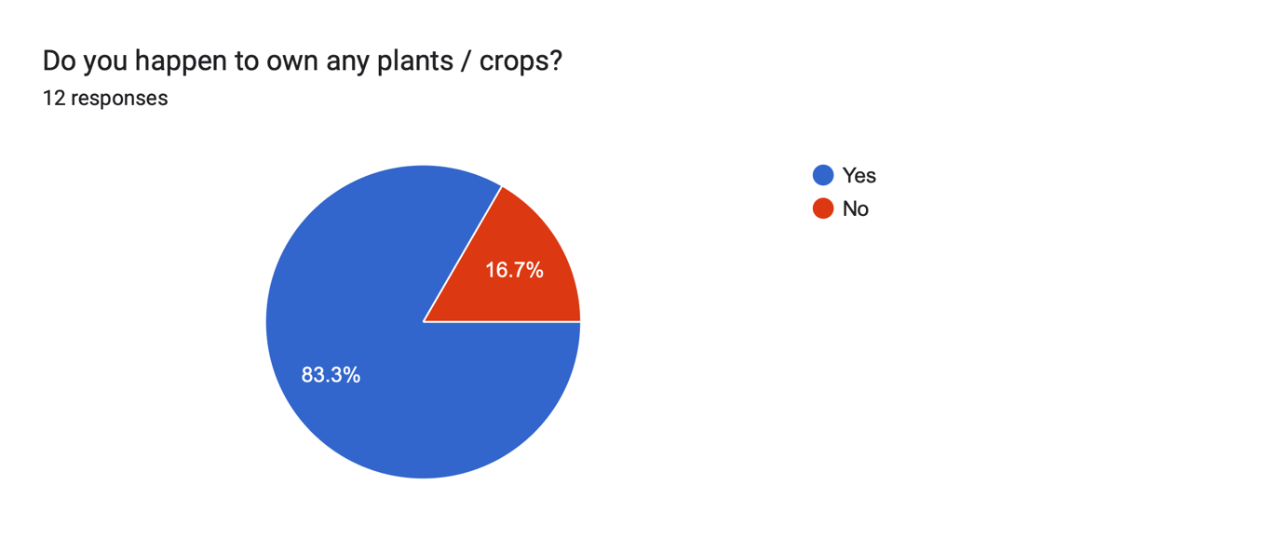

Figure 1 - Question 1

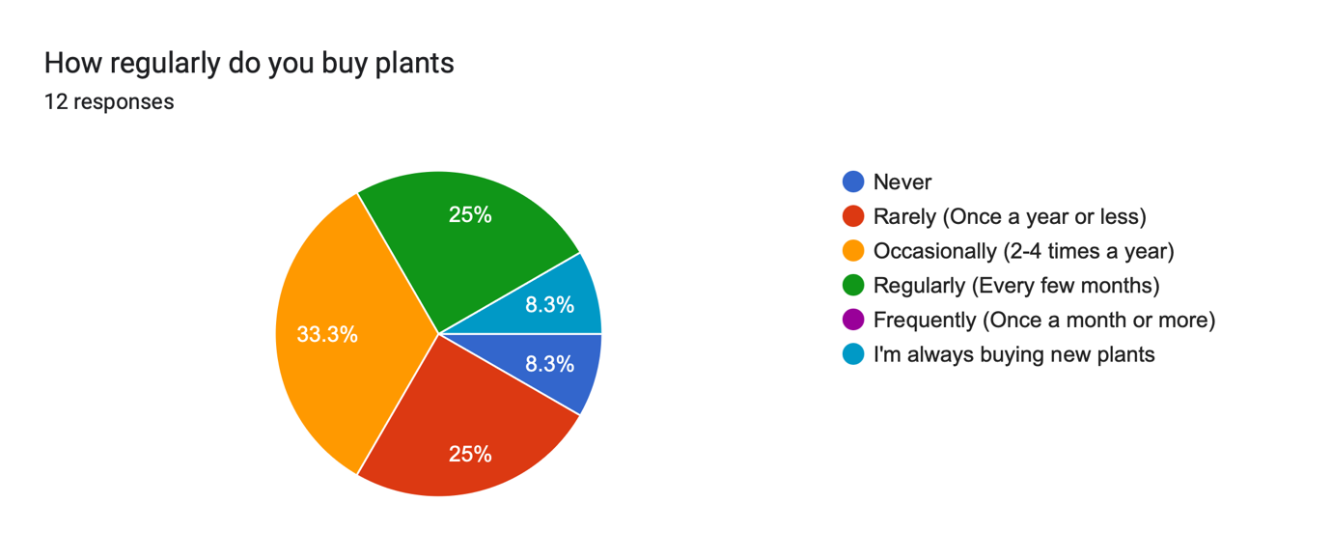

Figure 2 - Question 2

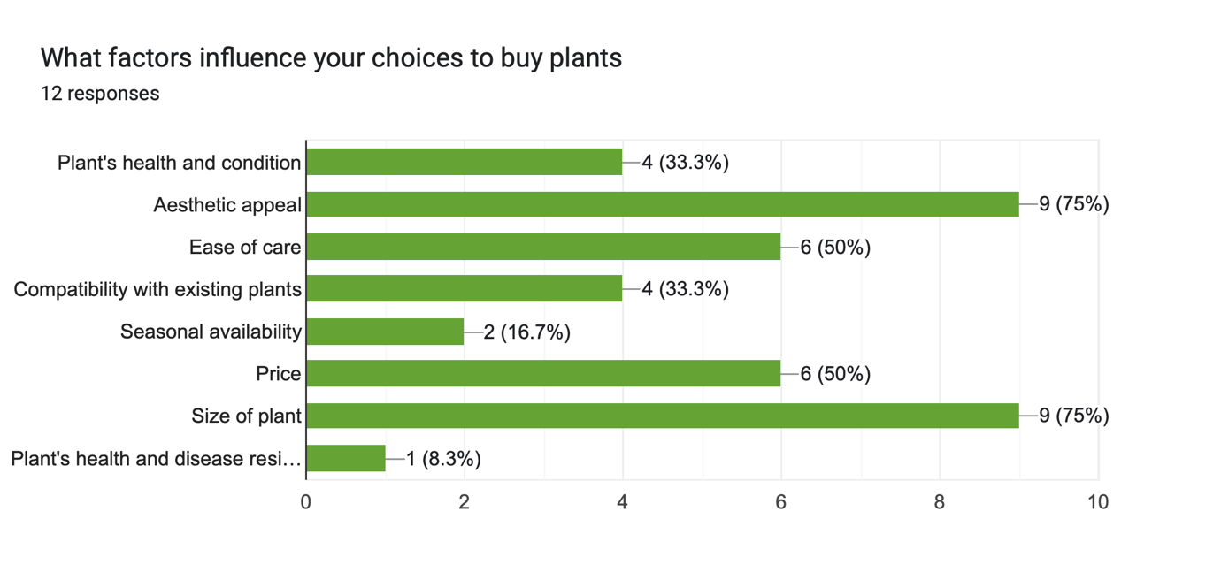

Figure 3 - Question 3

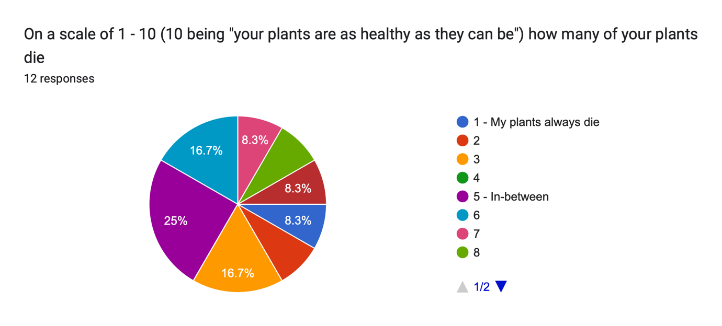

Figure 4 - Question 4

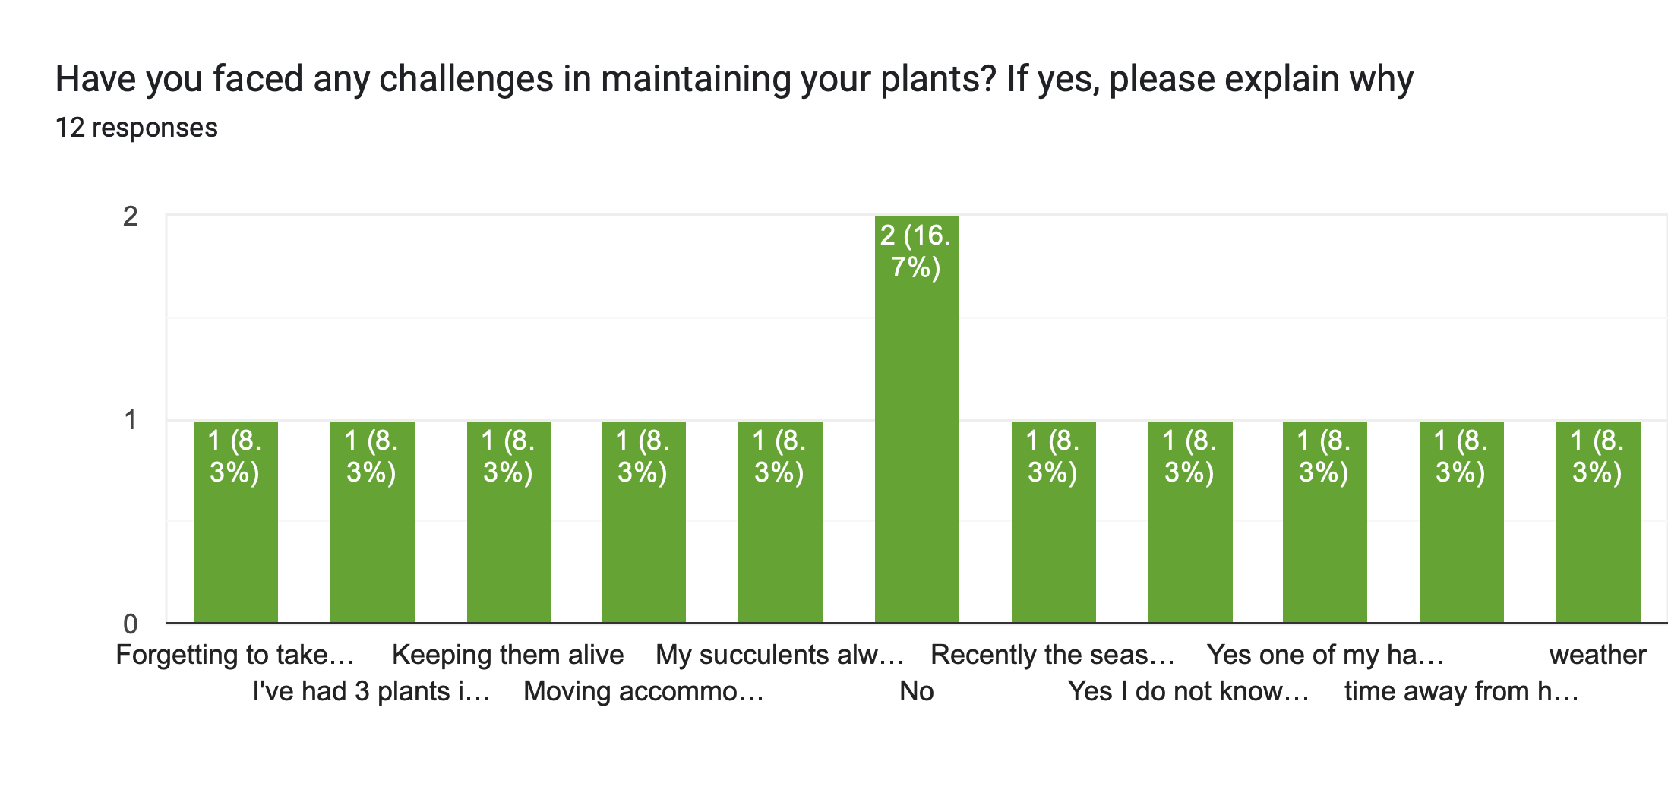

Figure 5 - Question 5

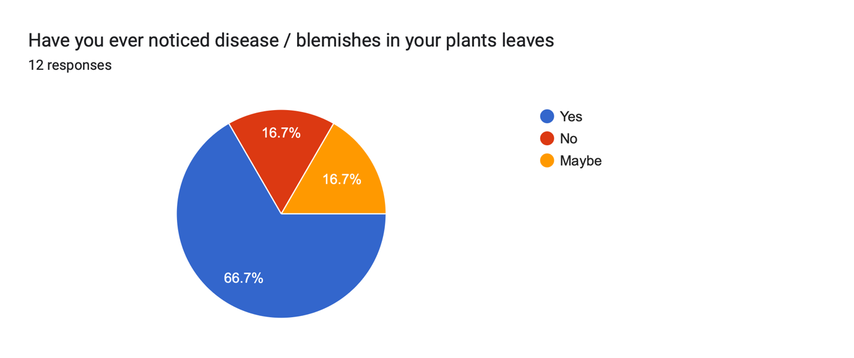

Figure 6 - Question 6

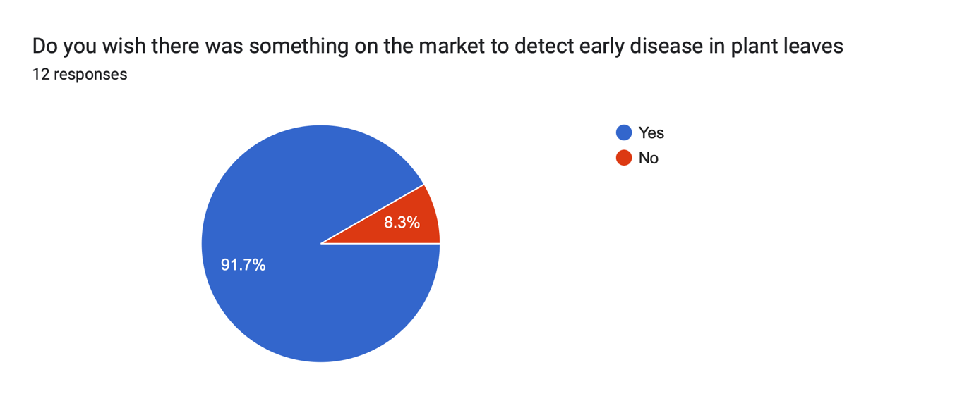

Figure 7 - Question 7

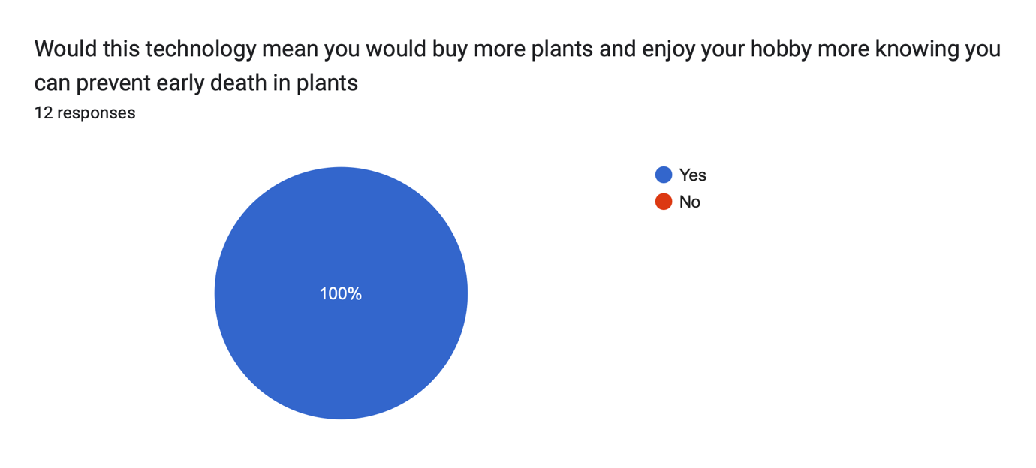

Figure 8 - Question 8

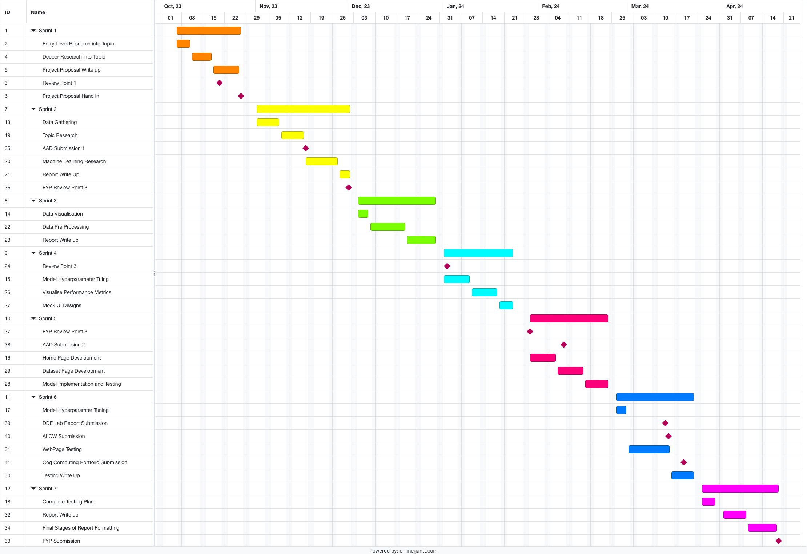

Figure 9 - Gantt Chart



Figure 10 - User Flow Diagram



Figure 11 - Sequence Diagram

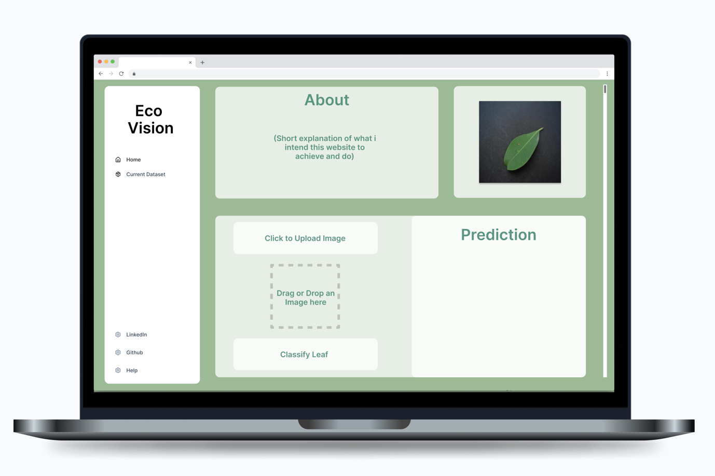

Figure 12 - Home Page UI

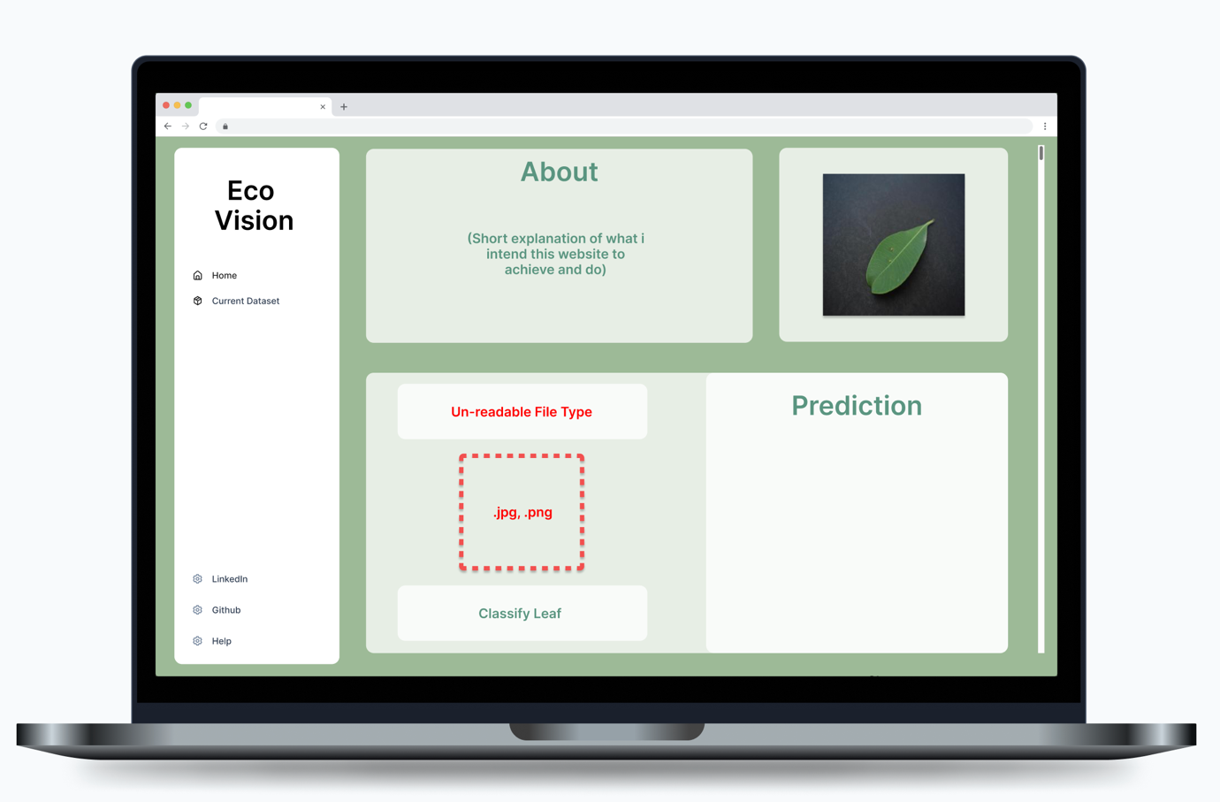

Figure 13 - Home Page UI | Incorrect File Format

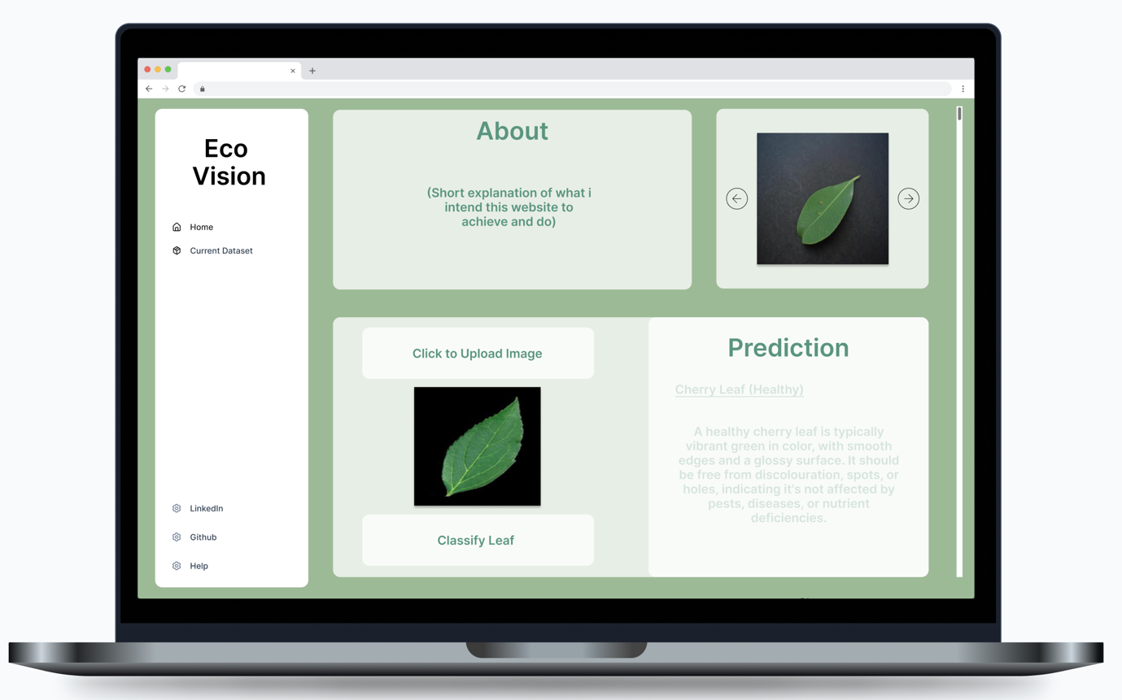

Figure 14 - Home Page UI | Image Classified



Figure 15 - Dataset Page UI



Figure 16 - Feedback / Help UI

Figure 17 - Bar graph representing Diseased Categories File Counts

Figure 18 - Bar graph representing Health Categories File Counts

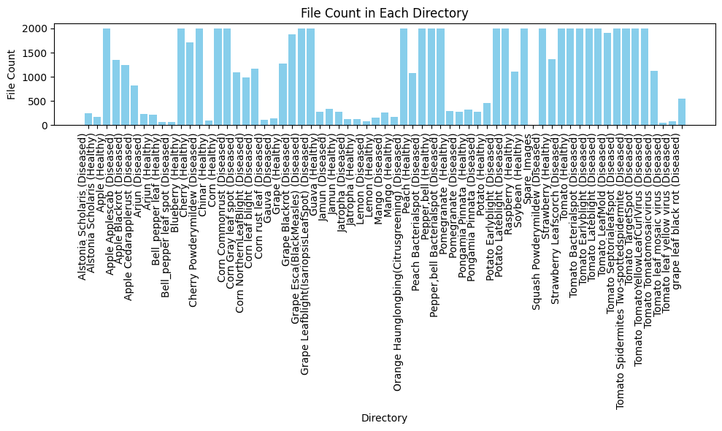

Figure 19 - Bar Graph after reducing max image count

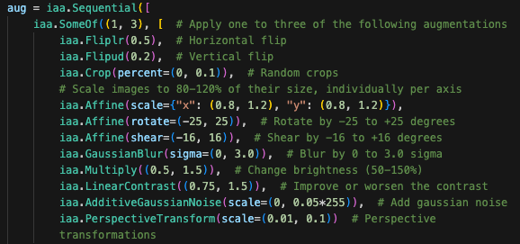

Figure 20 - Image augmentation code

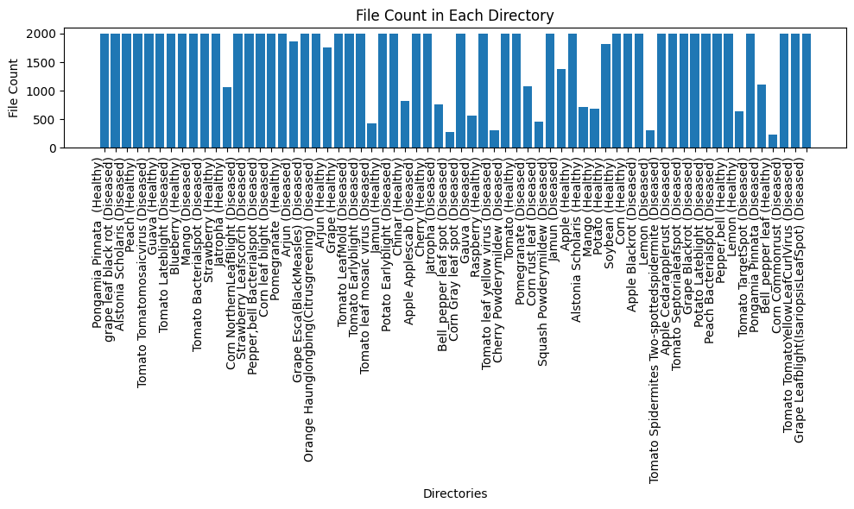

Figure 21 - Dataset after augmentation

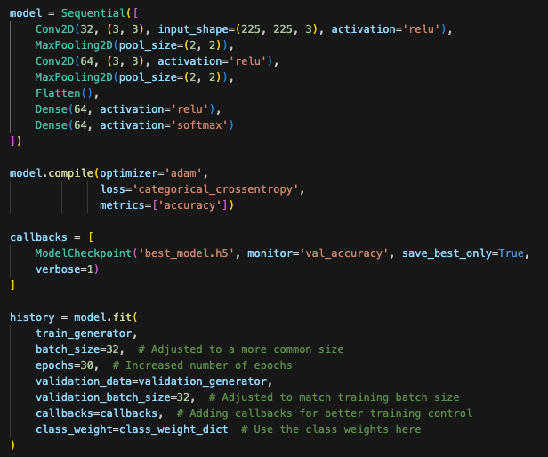

Figure 22 - Model Architecture



Figure 23 - Test count files in directory



Figure 24 - File count after Image Cap



Figure 25 - File count after Image Augmentation

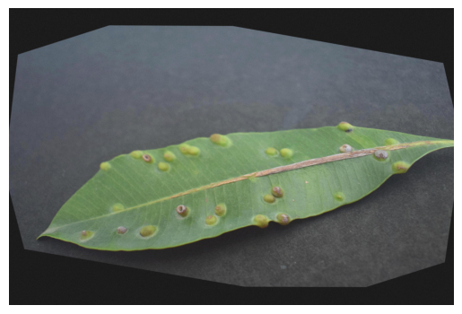

Figure 26 - Image Example after Image Augmentation

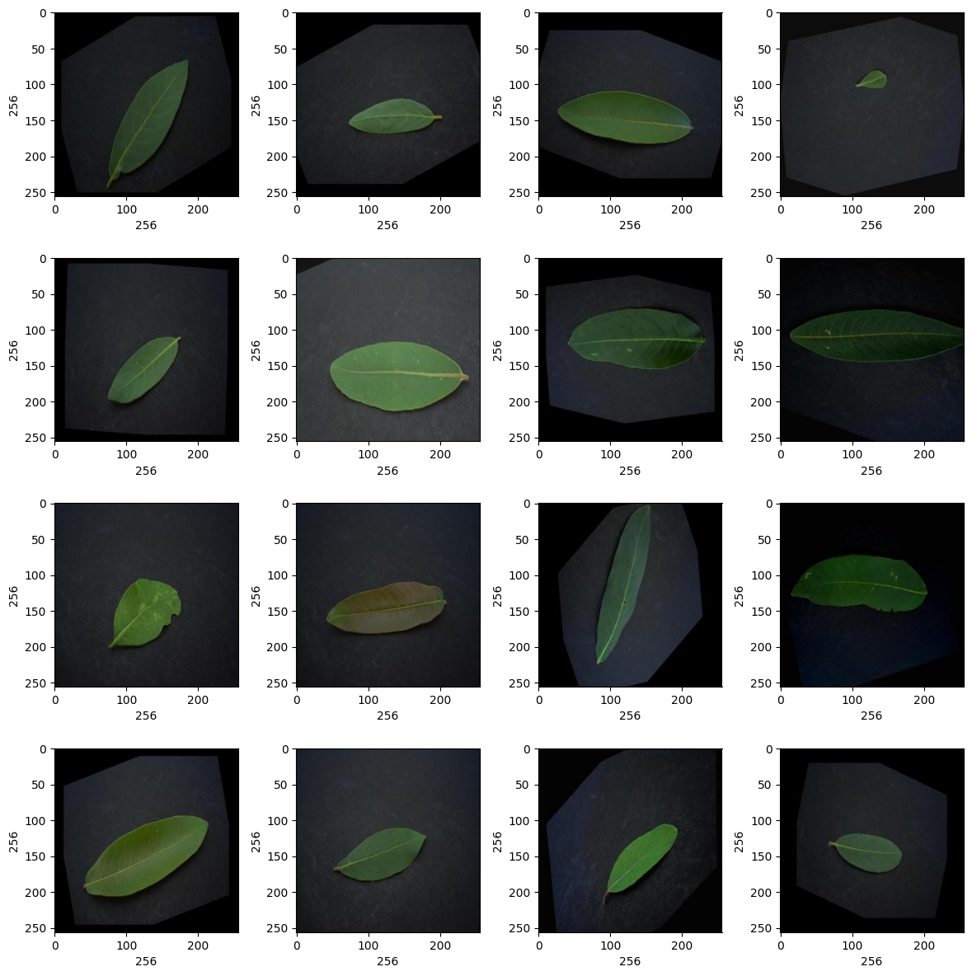

Figure 27 - Image Resize Test



Figure 28 - Test Remove Corrupted Files

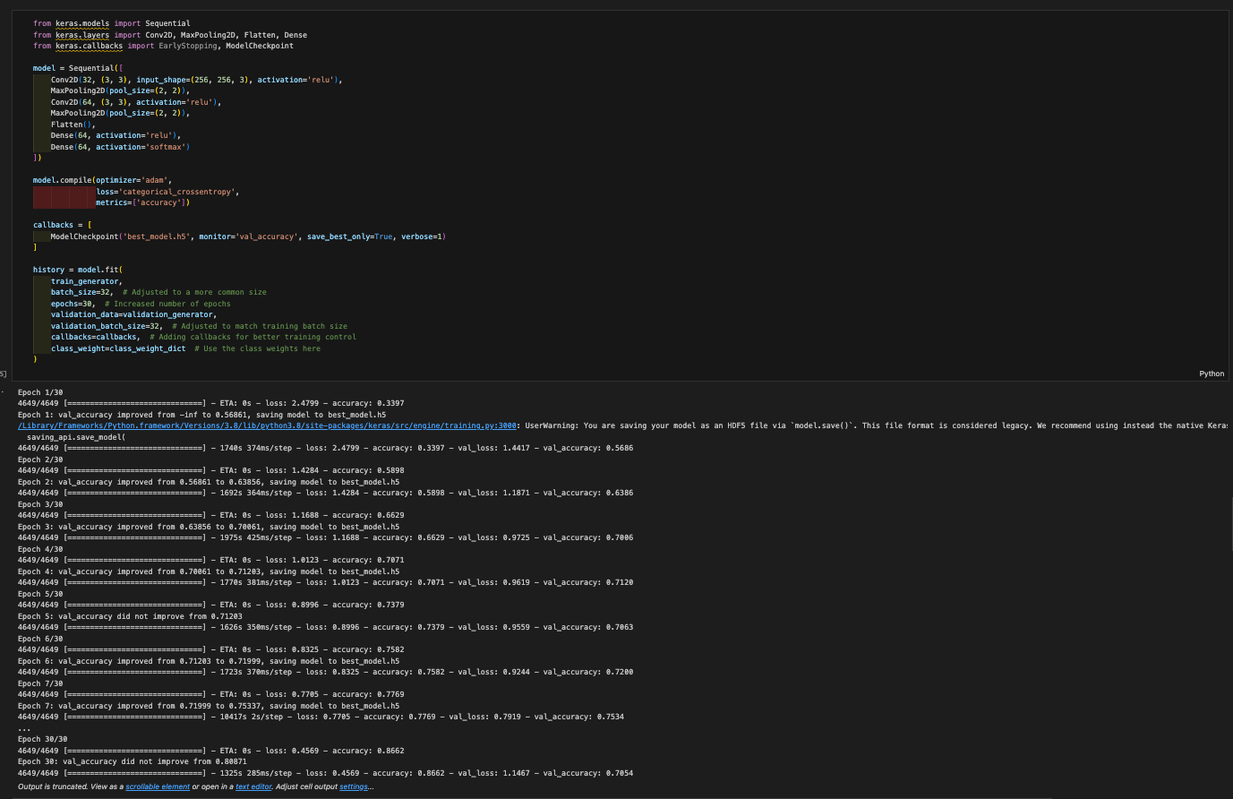

Figure 29 - Test Model Training

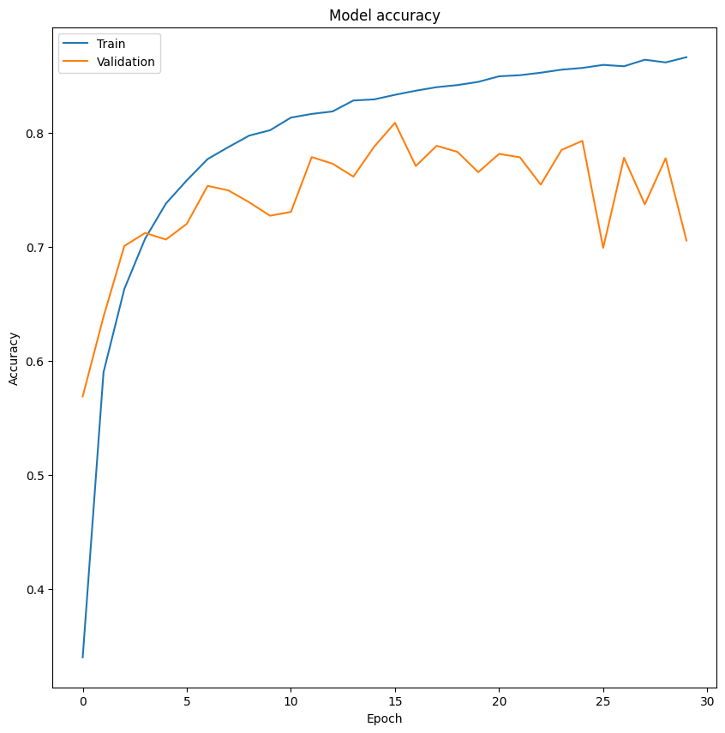

Figure 30 - Training and Validation Accuracy

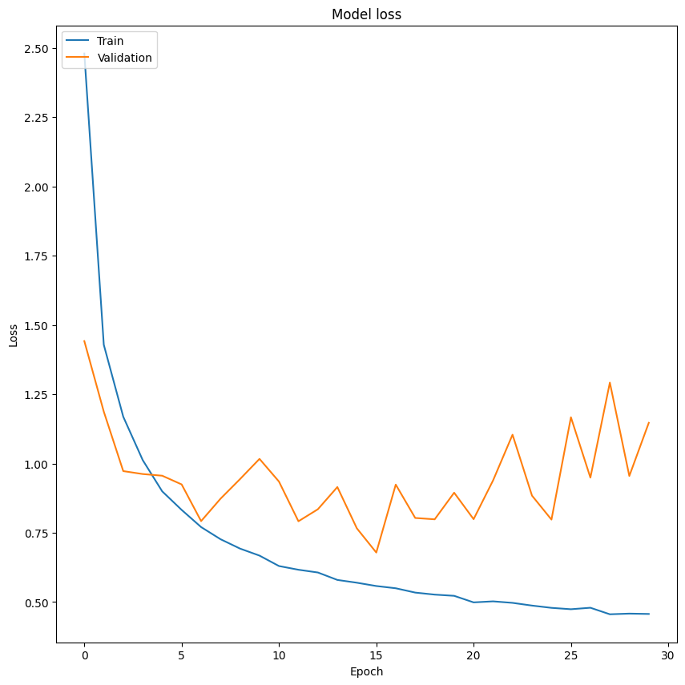

Figure 31 - Training and Validation Loss

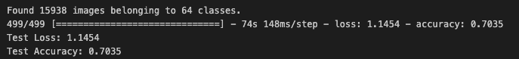

Figure 32 - Test Accuracy and Loss

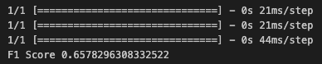

Figure 33 - F1 Score



Figure 34 - Image Upload Test



Figure 35 - Correct Prediction Output

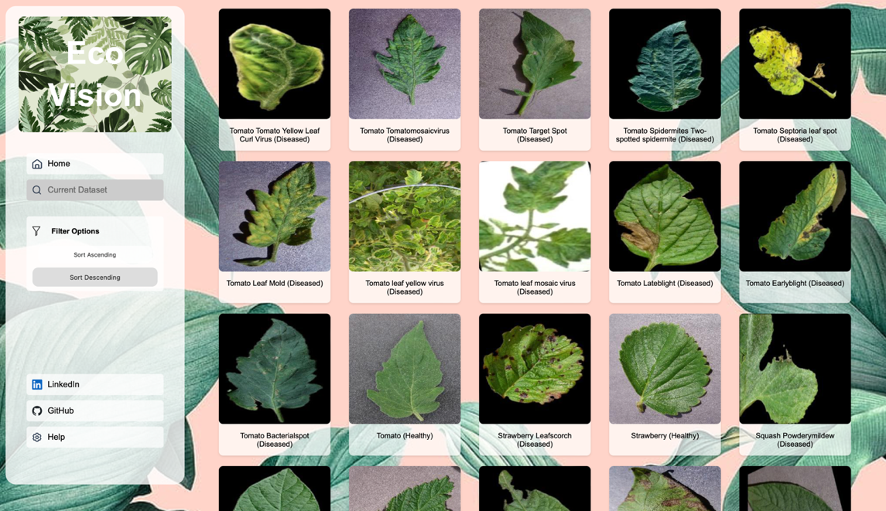

Figure 36 - Filters Test in Dataset

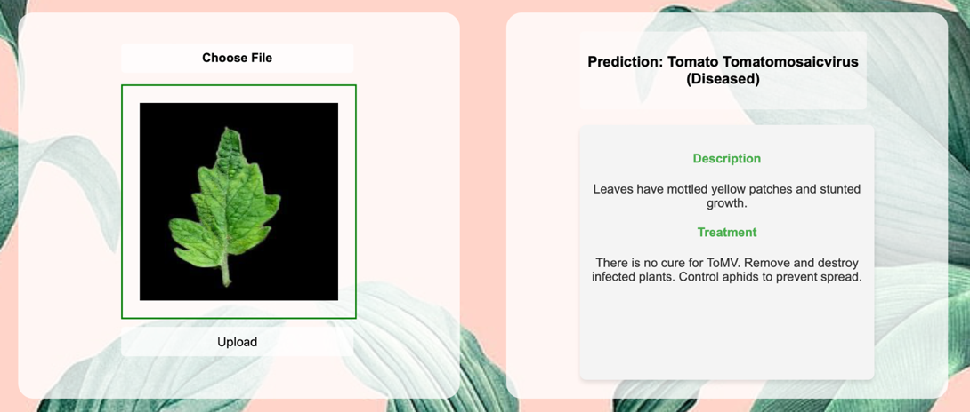

**Figure 37 - Accurate Descriptions for Plants with Disease**